GAME AND LEVEL DESIGN - LEVEL DESIGN DOCUMENT

**THE ELEVENTH DICE**

Stranger Things: BecominG 11

THE DEMOGORGON’S LAIR - Level 6

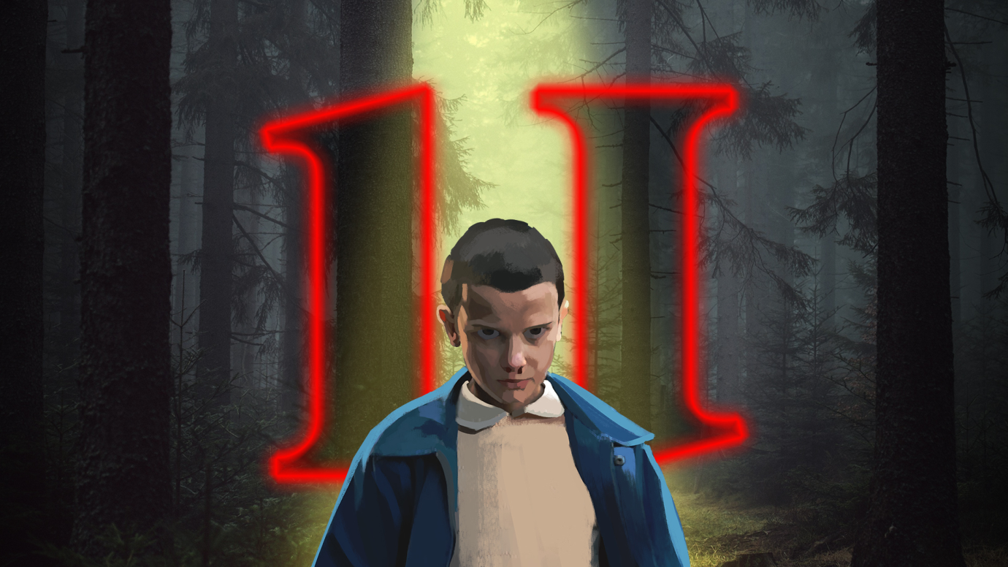

Maurizio Lu - 943827

maurizio.lu@studenti.unimi.it

Nicolò Buganza - 961149

nicolo.buganza@studenti.unimi.it

Matteo Malorgio - 931487

matteo.malorgio@studenti.unimi.it

Alessandro Compagnoni - N.A.

alessandro.compagnoni@studenti.unimi.it

Deborah Leonardi - 935754

deborah.leonardi@studenti.unimi.it

**DISCLAIMER**

**This document is not intended for the public. The rights of the images shown in it, if not original works, belong to their respective owners.**

**CHANGELOG**

|  |  |  |
| --- | --- | --- |
| Who | When | What |
| The Eleventh Dice | 21/10/2019 | Document created and writing of first ideas |
| Maurizio, Nicolò | 24/10/2019 | Document formatting |
| Maurizio | 30/10/2019 | Narrative elements added |
| The Eleventh Dice | 31/10/2019 | Look & Feel added |
| Deborah | 02/11/2019 | Settings added |
| Deborah, Maurizio | 03/10/2019 | High concept (story, game) added |
| Maurizio | 04/10/2019 | Goal outline added |
| Matteo, Alessandro | 05/11/2019 | Story flowchart, world diagram added |
| Deborah, Nicolò | 06/11/2019 | Characters, themes added |
| The Eleventh Dice | 07/11/2019 | Document revision for first milestone |
| Matteo, Deborah | 27/11/2019 | Minor revisions from first milestone, level story added |
| The Eleventh Dice | 28/11/2019 | Document revision for second milestone |
| Matteo, Maurizio, Alessandro | 11/12/2019 | Detailed level diagram and description added |
| Maurizio | 8/12/2019 | Scope of The game added |
| The Eleventh Dice | 12/12/2019 | Document revision for third milestone |
| Matteo | 18/12/2019 | Enemies Chart added |
| Maurizio | 19/12/2019 | Document header updated |
| Matteo | 22/12/2019 | Character and enemies sheets added |
| The Eleventh Dice | 04/01/2020 | Level description updated |
| Matteo | 08/01/2020 | Outcome prediction added |
| Maurizio | 09/01/2020 | Level Diagram updated |
| Matteo | 09/01/2020 | Blueprints and visual references of “The Demogorgon’s Lair” chapter updated |
| Matteo, Maurizio | 10/01/2020 | “Gameplay elements and Additional mechanics” chapter added |
| Matteo | 11/01/2020 | Skill Chart added |
| Alessandro | 13/01/2020 | Maze structure modified and detailed |
| Nicolò | 15/01/2020 | Visual Reference Website created - Added link to the document |
| Alessandro | 18/01/2020 | Event diagram added |
| The Eleventh Dice | 19/01/2020 | Document revision for last milestone |

Table of Contents

**1. High concept** 9

1.2 High level concept (game) 9

1.2 High level concept (story) 9

**2. Settings** 11

2.1. Hawkins Middle School (Tutorial Level) 12

2.2. Hawkins National Laboratory 12

2.3. The Mirkwood 13

2.4. The Junkyard 14

2.5. Will’s House 14

2.6. The Demogorgon’s Lair (Hawkins Public Library) 15

**3. Synopsis of the story** 17

**4. Story Flowchart** 18

**5. Themes** 20

**6. Characters** 21

6.1. Bad Eleven 21

6.1.1. Description 21

6.1.2. Circumplex 21

6.1.3. Map of the relations with other characters 22

6.2. Good Eleven 23

6.2.1. Description 23

6.2.2. Circumplex 24

6.2.3. Map of the relations with other characters 25

6.3. Demogorgon 25

6.3.1. Description 25

6.3.2. Circumplex 26

6.3.3. Map of the relations with other characters 27

6.4. Kali Prasad (8) 27

6.4.1. Description 28

6.4.2. Circumplex 28

6.4.3. Map of the relations with other characters 29

6.5. Raiden (1) 29

6.5.1. Description 30

6.5.2. Circumplex 30

6.5.3. Map of the relations with other characters 31

6.6. Guilherme (9) 31

6.6.1. Description 31

6.6.2. Circumplex 32

6.6.3. Map of the relations with other characters 33

6.7. Catinca (3) 33

6.7.1. Description 33

6.7.2. Circumplex 34

6.7.3. Map of the relations with other characters 35

6.8. Abazu (7) 35

6.8.1. Description 35

6.8.2. Circumplex 36

6.8.3. Map of the relations with other characters 37

6.9. Zasha (5) 37

6.9.1. Description 38

6.9.2. Circumplex 39

6.9.3. Map of the relations with other characters 40

**7. World Diagram** 41

**8. Goal Outline** 42

8.1. Hawkins Middle School42

8.2. Hawkins Laboratory, Upper Floors 42

8.3. Mirkwood 42

8.4. The Junkyard 43

8.5. Will's House and Castle Byers 43

8.6. The Demogorgon's Lair 43

8.7. Real Hawkins 43

8.8. Hawkins Laboratory, Lower Floors 44

**9. Scope of the Game** 45

**10. Enemies Chart** 47

**11. Skill Chart** 48

**12. Gameplay elements and Additional mechanics** 49

12.1. Bad Eleven’s health and power bar 49

12.2. Checkpoints and game saves 51

12.3. Items 51

12.3.1. Consumable items 51

12.3.2. Collectible items 52

**13. Character and Enemies sheets** 53

13.1. Introductory notes 53

13.2. Bad Eleven 54

13.2.1. Description 54

13.2.2. Statistics 54

13.2.3. Movements 55

13.2.4. Powers 55

13.2.5. Skill details 55

13.3. Demodog 58

13.3.1. Description 58

13.3.2. Statistics 58

13.3.3. Actions 59

13.4. Puppy Demodog 60

13.4.1. Description 60

13.4.2. Statistics 60

13.4.3. Actions 61

13.5. Burly Demodog 62

13.5.1. Description 62

13.5.2. Statistics 62

13.5.3. Actions 63

13.6. Demogorgon 65

13.6.1. Description 65

13.6.2. Statistics 65

13.6.3. Actions 66

13.6.4. Finite state machine 66

13.7. Sample encounters 67

13.7.1. Example of easy encounter 67

13.7.2. Example of hard encounter 69

**14. The Demogorgon’s Lair Level** 71

14.1. Story 71

14.2. Event diagram 82

14.3. Level diagram & Description 82

14.3.1. Hawkings library ground floor 86

14.3.2. Hawkings library first floor 90

14.3.3. Hawkings library archives 95

14.3.4. Demogorgon’s Caves 96

14.3.5. Maze 97

14.3.6. Demogorgon’s Lair 98

**15. Look & Feel** 103

# 1. High concept

## 1.1 High level concept (game)

The game is a single player 3D first person survival horror game, based on the Netflix series *Stranger Things*. Although it features a full real time gameplay (both exploration and combat system), the game is based on the rules of Dungeons & Dragons (fifth edition), conveniently adjusted in order to fit the game best (see chapter 12). The protagonist of the journey is an evil copy of Eleven (Bad Eleven, B11 from now on) generated from the energy created during the fight between the real Eleven (Good Eleven, G11 from now on) and the Demogorgon, the main antagonist of the series until the end of the first season. See section 6 for more details.

The game consists of a sequence of eight chapters and a tutorial. The first and last will mostly require exploration, whereas the central chapters will be characterized by a miniboss and composed by a series of levels. The main tasks required to the player are exploration and puzzle solving in order to find, acquire and learn new skills and powers (super-speed, mind-control, etc...) from other children living in the Upside Down (see section 1.2). Some of those powers are useful, but most of them are compulsory in order to advance within the game. In order to acquire them, the player must find a special object, linked to the children’s past and to the real world (like Eleven’s puppet), which will trap the child’s soul once they are dead. When they are killed, the children turn into sand and enter the object the player has found.

## 1.2 High level concept (story)

After the defeat of the Demogorgon, two copies of Eleven wake up in the Upside Down. G11 easily passes the gate and goes back to the real world, but B11 remains stuck in the Upside Down, because she, like everything else there, is a copy of something already existing in the actual world. She decides to move to Hawkins Laboratory, to try to pass the gate G11 opened at the beginning of the series and that should still be there. She can’t reach the gate, but she discovers that some of the other children involved in the experiments generated copies like her, that are living in the Upside Down, and she decides to try to take their powers in order to track G11, kill her and take her place in the real world.

She manages to kill a few, but she starts to feel guilty, especially because she can hear the thoughts of the dead children and see their past and their sufferings. She finds out that the last child she has to kill is a little girl who can control the minds of every creature she encounters, and she knows that she needs to befriend her and betray her. As they become friends, B11 feels more and more guilty, until the other children push her to kill the girl. Having acquired the last power needed, B11 controls the Demogorgon to reach the gate in the Laboratory but she still can’t pass it. She understands that she needs to kill G11 in order to do so, so she passes the gate in the body of the Demogorgon, finds G11 and lures her into the Upside Down.

Being a copy, B11’s powers are much weaker than the powers of G11. During the last fight, B11 understands this and enters the mind of the Demogorgon, only to see herself killed by G11. The last things she sees are the souls of the trapped children being freed from the objects and her body turning into sand to join them. Together, they become the Mind Flayer.

# 2. Settings

All the events take place in Hawkins. The player will not be able to move freely on the map, but he will have to follow the linear structure of the game. However, the map has been designed in order to make the locations look as close as possible to one another.

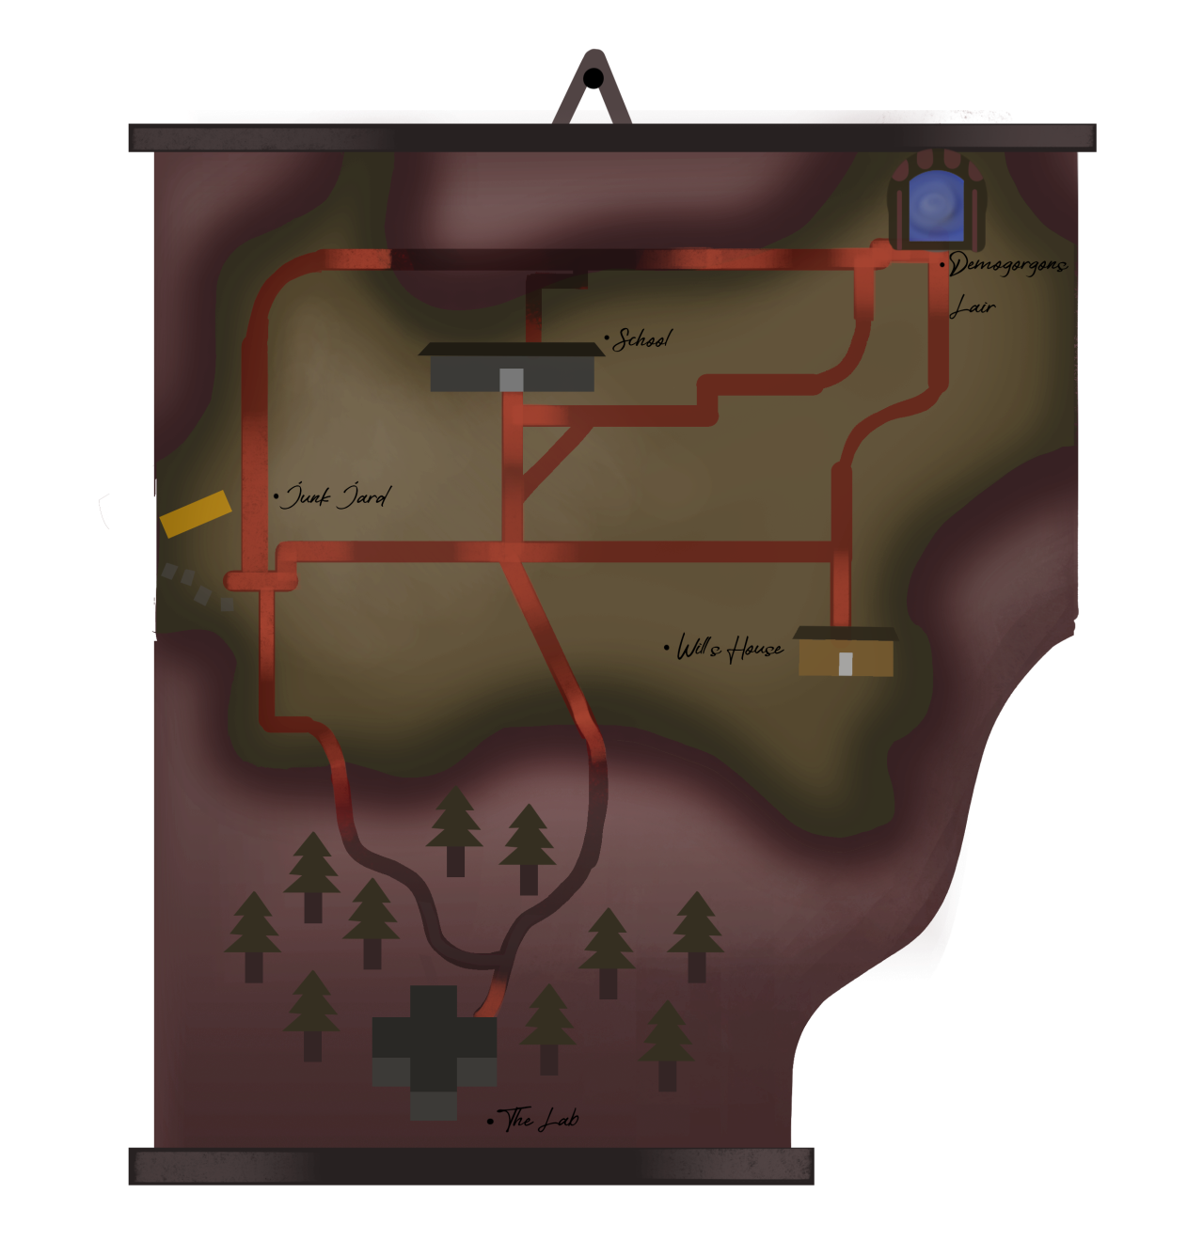

(Hawkings Map)

## 2.1. Hawkins Middle School (Tutorial Level)

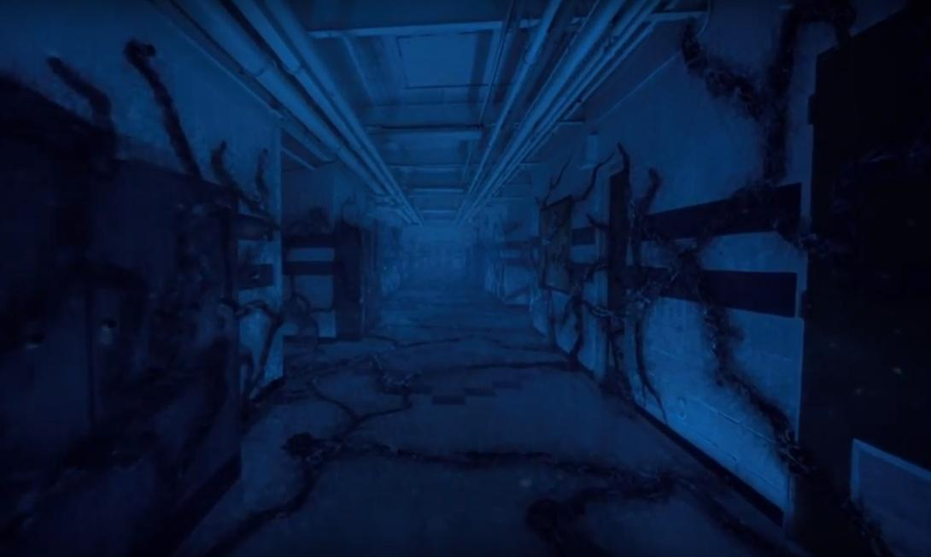

(Screenshot from *Stranger Things*, season 2, episode 2)

Since, as seen in season two of the series, Eleven finds herself in the Upside Down version of Hawkins MIddle School, it is fair to think that the bad copy would also appear there. As the game begins, this is the place where B11 sees G11 for the first time, and where she finds out she needs to find another gate to get to the real world. The player can have a tutorial of the game’s dynamics while trying to get out of the school.

## 2.2. Hawkins National Laboratory

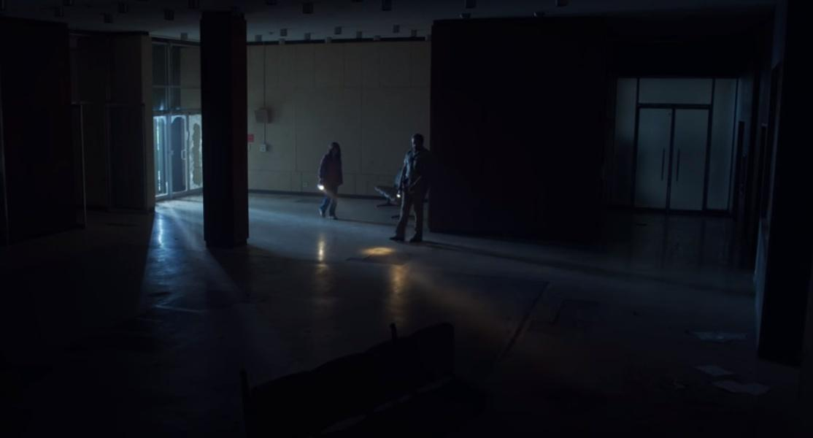

(Screenshot of the Laboratory Hall from *Stranger Things*, season 3, episode 3)

The Laboratory is run by the Department of Energy and is located south of the town of Hawkins. It has seven floors, three of which underground. The hall and the ground floor are the locations of the first introductory chapter. The second chapter will take place in the floors above, whereas the final one will be set underground. At the fourth floor the player will find the first boy, Raiden, and will have a chance of testing his superpower after killing him. There will be a special room, the Rainbow Room, which, if opened, will unlock a special character: Kali.

## 2.3 The Mirkwood

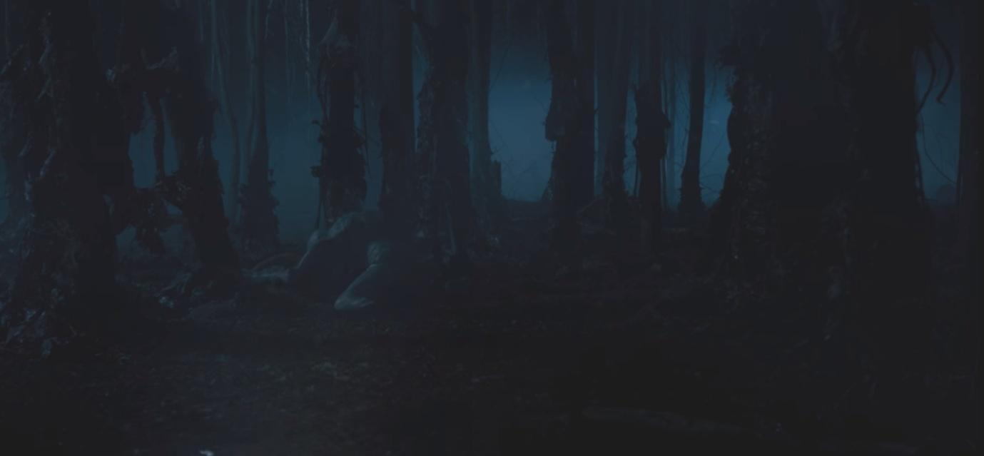

(Screenshot from *Stranger Things* season 1, episode 5)

Mirkwood is the name the protagonists of the series have given to the woods outside of the Laboratory, in which the Demogorgon hunts. It is very dark and it looks like a maze. Here the player will have to find Guilherme, a boy who can control fire. They will also be able of burning trees for testing the ability after having learnt it.

2.4. The Junkyard

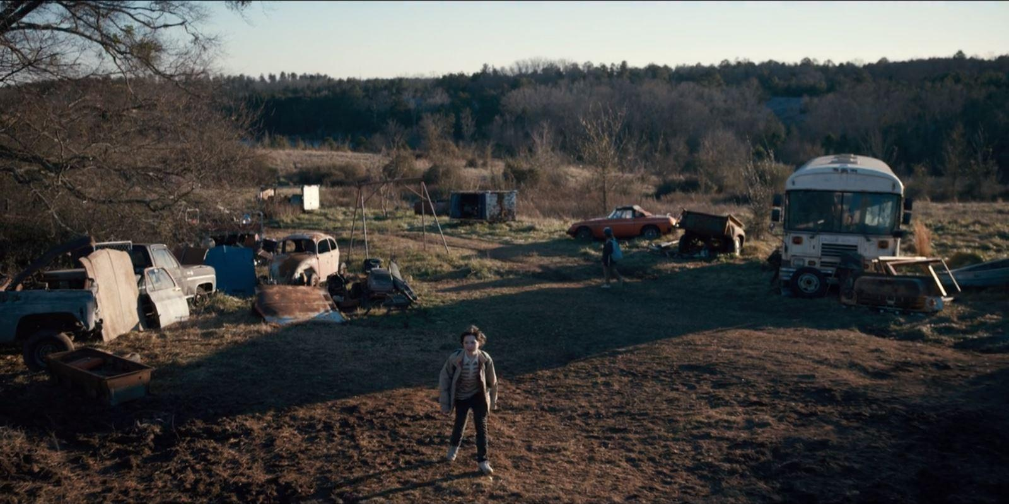

(Picture from Google Images)

The Junkyard is a safe place for the protagonists of the series, but it will be dangerous, dark, and full of monsters in the game. The player will have to fight Catinca, a girl with the power of levitation, but in order to reach her they must avoid a series of traps and monsters looking for them. While solving the puzzles, moreover, the player has to be careful not to be seen by the girl, hiding in the broken bus.

2.5. Will’s House and Castle Byers

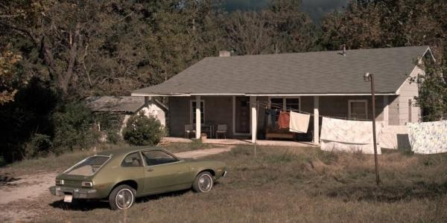

(Picture from *Stranger Things* Wiki)

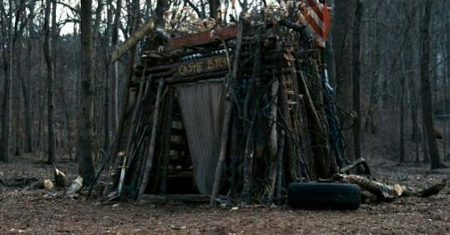

(Picture from Google Images)

Byers House is quite small and only has one floor. It has a living room, a kitchen, a small hallway which leads to the bedrooms. In the living room the player will face a puzzle with the famous lights seen in the show. They will also be able to explore the garage and Castle Byers, the small construction Will and his brother built in the woods near the house. In order to kill the child living here, Abazu, the player must attract him out of the house to investigate about his powers and then shoot him from afar, with a rifle placed in the garage.

## 2.6. The Demogorgon’s Lair (Hawkins Public Library)

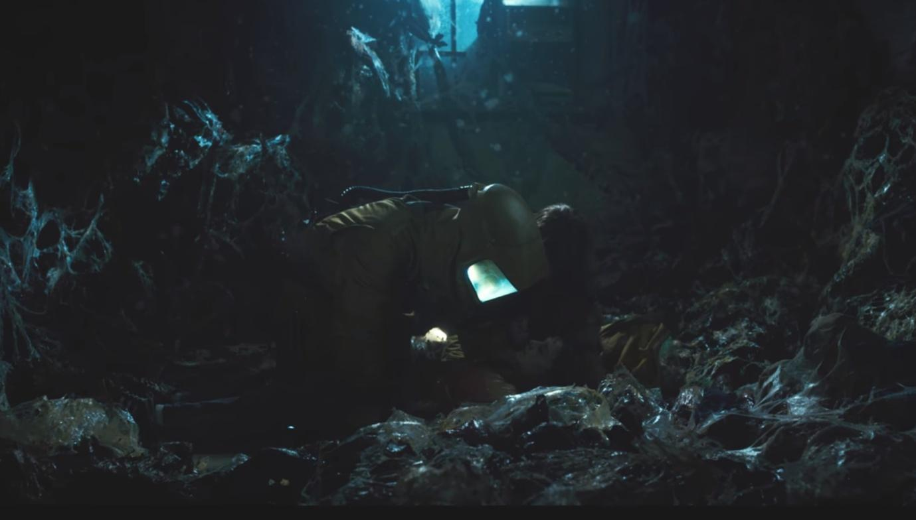

(Screenshot from *Stranger Things* season 1, episode 8)

The Demogorgon lives in the Upside Down version of the Hawkins Public Library. While only the ground floor is shown in the series, in the game the first floor and the underground will be available too. Once entered, the player will see a main desk, some tables and some bookshelves, where bodies the Demogorgon has caught lie. On the upper floor lives the little Zasha, untouched by the monster. In order to befriend her, the player must first use Abazu’s power and then carry out some tasks in the basement. Once B11 and Zasha are friends, they will both lie down to sleep on the upper floor of the Library and tell each other stories of their past. Here B11 will stab Zasha to death and get her power. The Demogorgon, sensing blood, will arrive, and B11 will have to control its mind in order to save herself.

3. Synopsis of the story

The story is divided in three acts.

First Act: B11 is generated in the Upside Down - the death of Catinca

B11 arrives in the Upside Down, decides that she wants to get out and return in the real world (of which she has only the memories she shares with G11) and begins her journey. She finds out that there are other children like her and realizes that she could take their powers to defeat G11.

Second Act: the death of Catinca - the death of Zasha

After killing Catinca, B11 begins to regret what she has done. She thinks that she had no right to kill the others and she starts to wonder how G11 feels like, being good and living a peaceful life out of the Upside Down. When she befriends Zasha, she feels important and trusted by someone for the first time, until the other children she killed remind her that she must finish what she began if she truly wants to get out of the hell she is living in. She lets them get to her head and kills Zasha, which causes her a great pain.

Third Act: the death of Zasha - B11 dies and becomes the Mind Flayer

Having killed her only friend, B11 is now determined to get to the real world, even if this means killing her other half to take her place. She can now control the Demogorgon and using his body she attracts G11 in the Upside Down to kill her. However, she is too weak and is killed. Her soul merges with the souls of the other children and becomes the Mind Flayer, seeking revenge for everything they have been through by the only way possible: destroying everything and everyone.

# 

# 

# 4. Story Flowchart

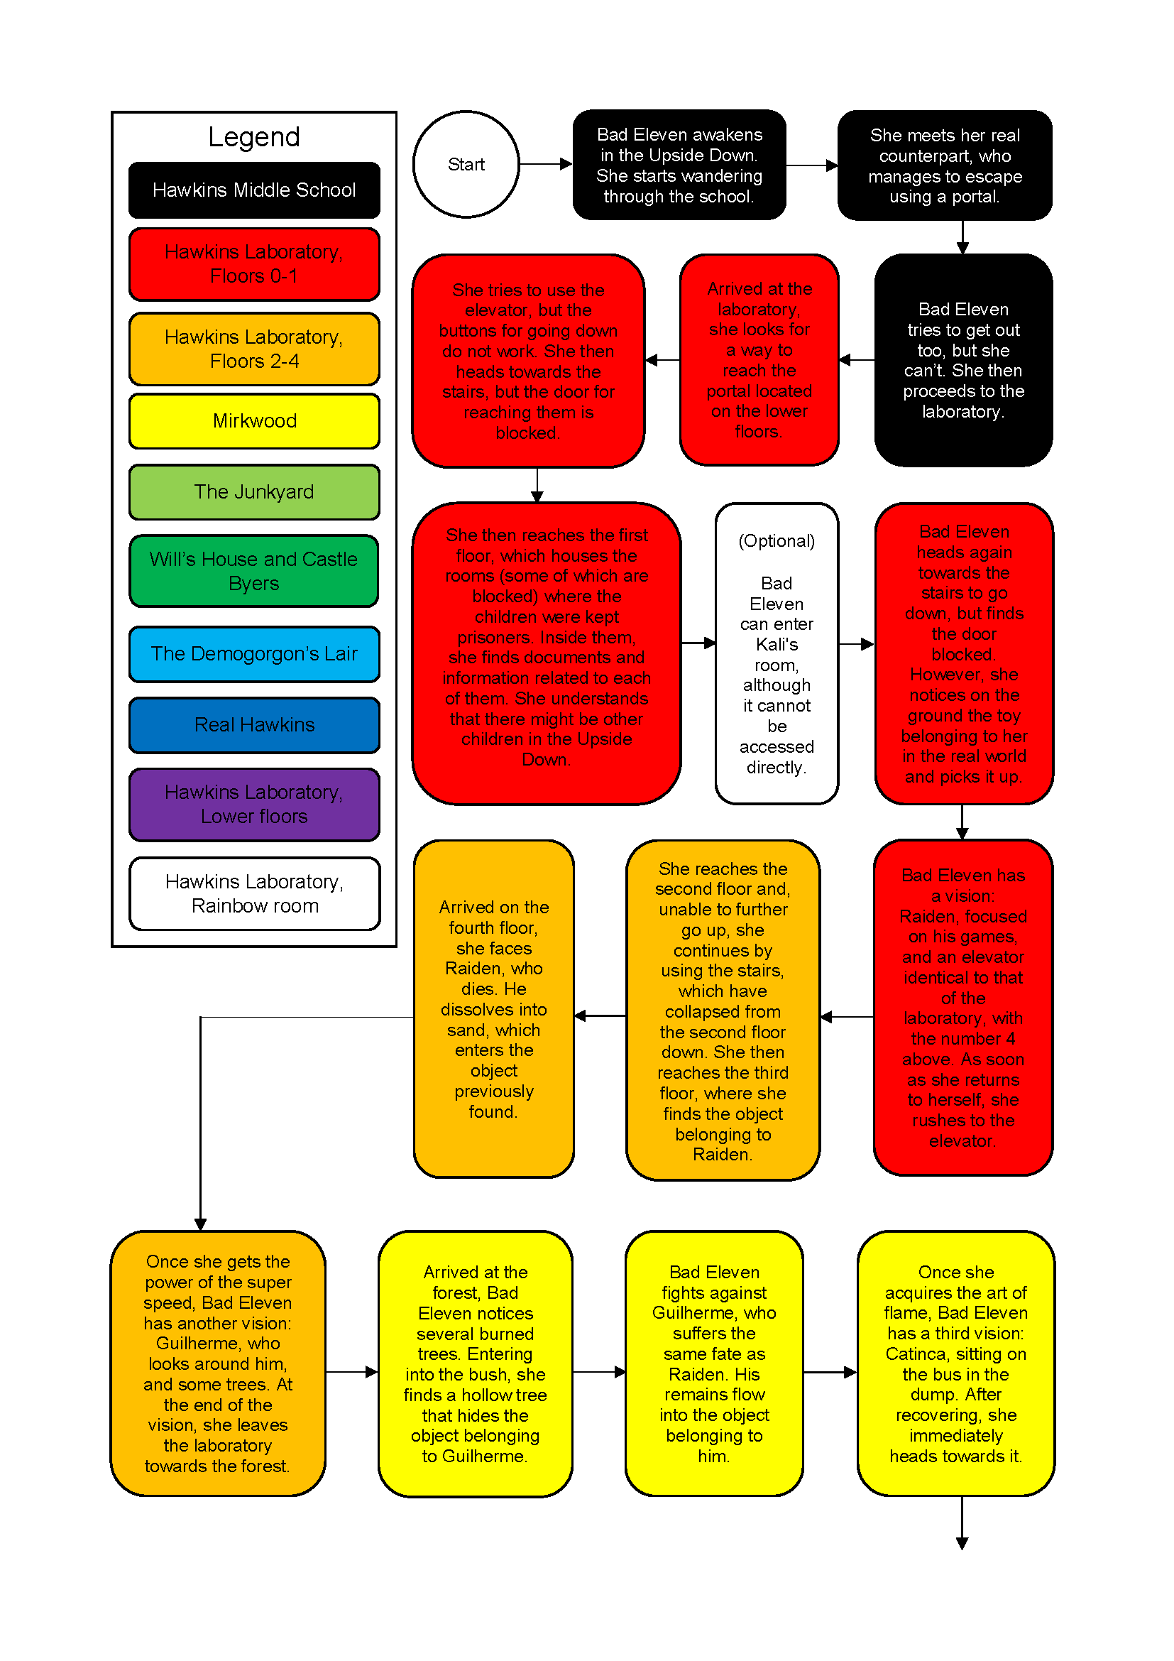

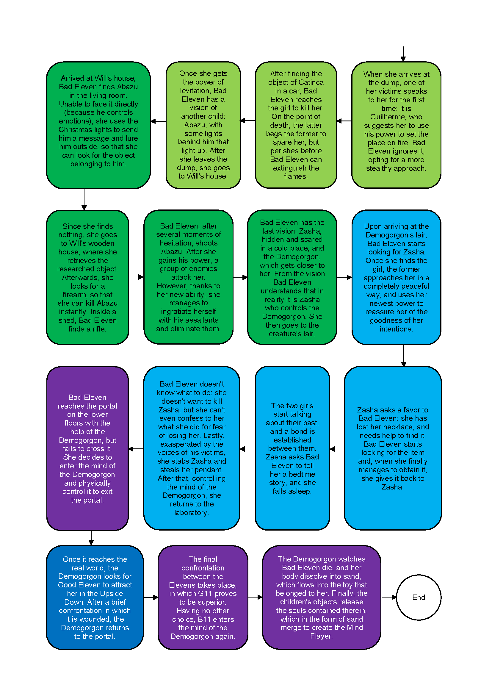

# 5. Themes

Betrayal  
The act of betrayal concerns the violation of someone’s trust or confidence or of something considered as a moral standard. This definition can be translated in the game using the relation that Bad Eleven maintains with Zasha. At the beginning, it seems that the two girls are friends, each one caring and trusting each other, but in the end Bad Eleven will reveal her true intentions, backstabbing Zasha just to accomplish her true will.

Stolen Childhood

All the children, sooner or later, experienced the tragedy of being kidnapped and separated from their family in order to be studied in Dr. Brenner’s laboratories. Such theme is ever-present in the game thanks to the flashbacks that Bad Eleven will experience after having absorbed one child’s power.

Guilt

Although betrayal is contemplated, guilt is also an integral part of Bad Eleven’s mind and personality who, as the game progresses, will be consumed by it. In any case, she won’t be able to support such a deep condition, leading to the continuation of her murders.

Doubt

Doubt can be described as not being certain about or convinced of something. As the story develops, Bad Eleven will face the struggle of the other guys’ memories coexistence in her mind, creating the internal doubt of whether her actions are good or not. As the game progresses, these flashbacks will become stronger and stronger, almost paralyzing Bad Eleven.

Power

Searching for more powers and abilities in order to pass the gate leading to the real world is Bad Eleven’s ultimate desire. With this in mind she will wander the Upside Down, searching for other children of the Laboratory experiments, in order to absorb their powers and thus going back to the real world, replacing the authentic and ever-stronger Good Eleven.

# 6. Characters

## Bad Eleven

### 

(Screenshot from Stranger Things season 1)

### 6.1.1. Description

As the real Eleven killed the Demogorgon, a wave of energy created a bad copy of her in the Upside Down. She shares Good Eleven’s memories and powers, but she is much weaker and, being a copy, she can’t pass the gate to enter the real world. Her main goal is going back there and taking the place of Good Eleven, because she knows what the real world looks like and she doesn’t want to live in the Upside Down. After having met and killed the other children, this feeling grows stronger, because she doesn’t want to become like them. However, as she hears their stories and shares their memories, she starts to feel guilty and sad for them and for what they had to suffer. She will eventually be killed by Good Eleven and after becoming the Mind Flayer her main goal will be to destroy everything and to control the whole real world, in order to never have to suffer again.

Her object is a puppet, as shown in the first season of the series.

### 6.1.2. Circumplex

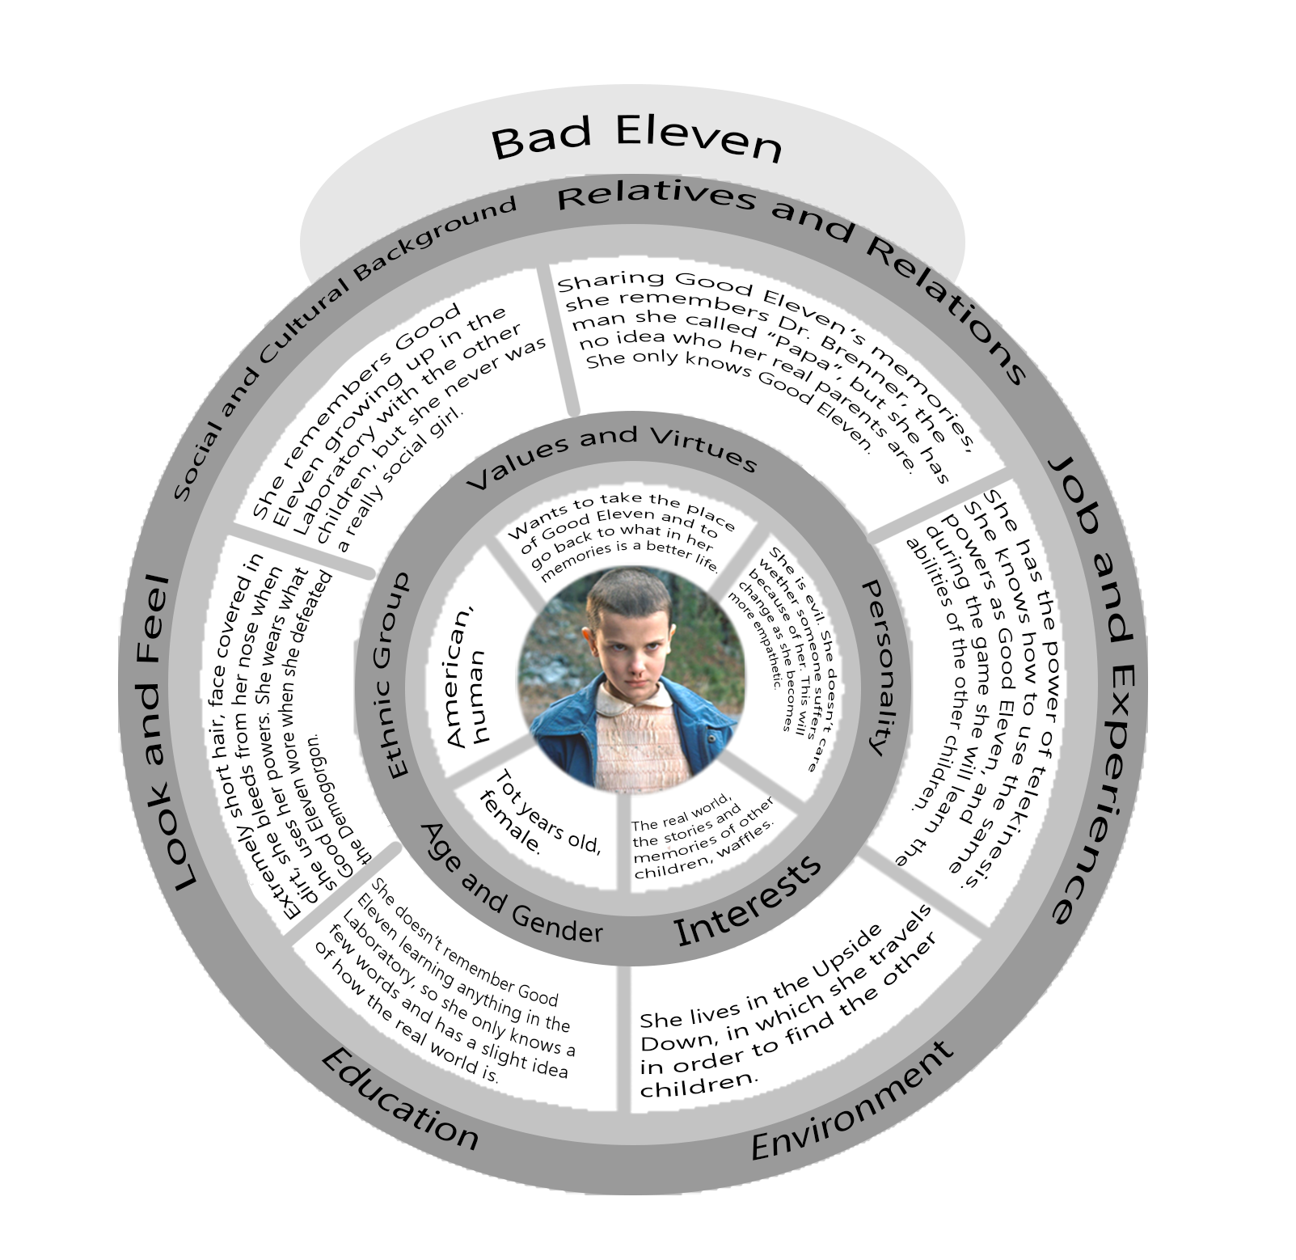

### 6.1.3 Map of the relations with the other characters

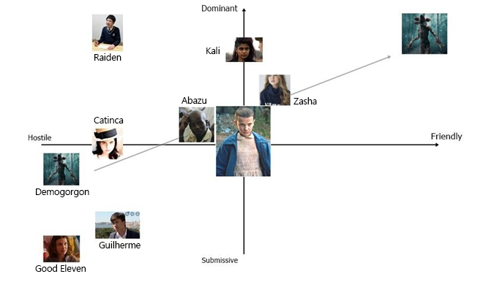

6.2. Good Eleven

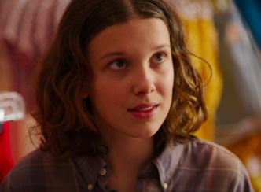

(Screenshot from Stranger Things)

6.2.1. Description

She is a young girl, who has lived all her life in the Hawkins Laboratory as an experiment. It was her who opened the gate to the Upside Down in the underground floors of the Laboratory. After this she ran away and was found by the protagonists, who taught her how to live in the real world, which she had never seen before. She is shy, needs to learn how to speak, but she is kind and loving, and she doesn’t want the ones she loves to get hurt. Her powers are much stronger when she gets angry.

6.2.2. Circumplex

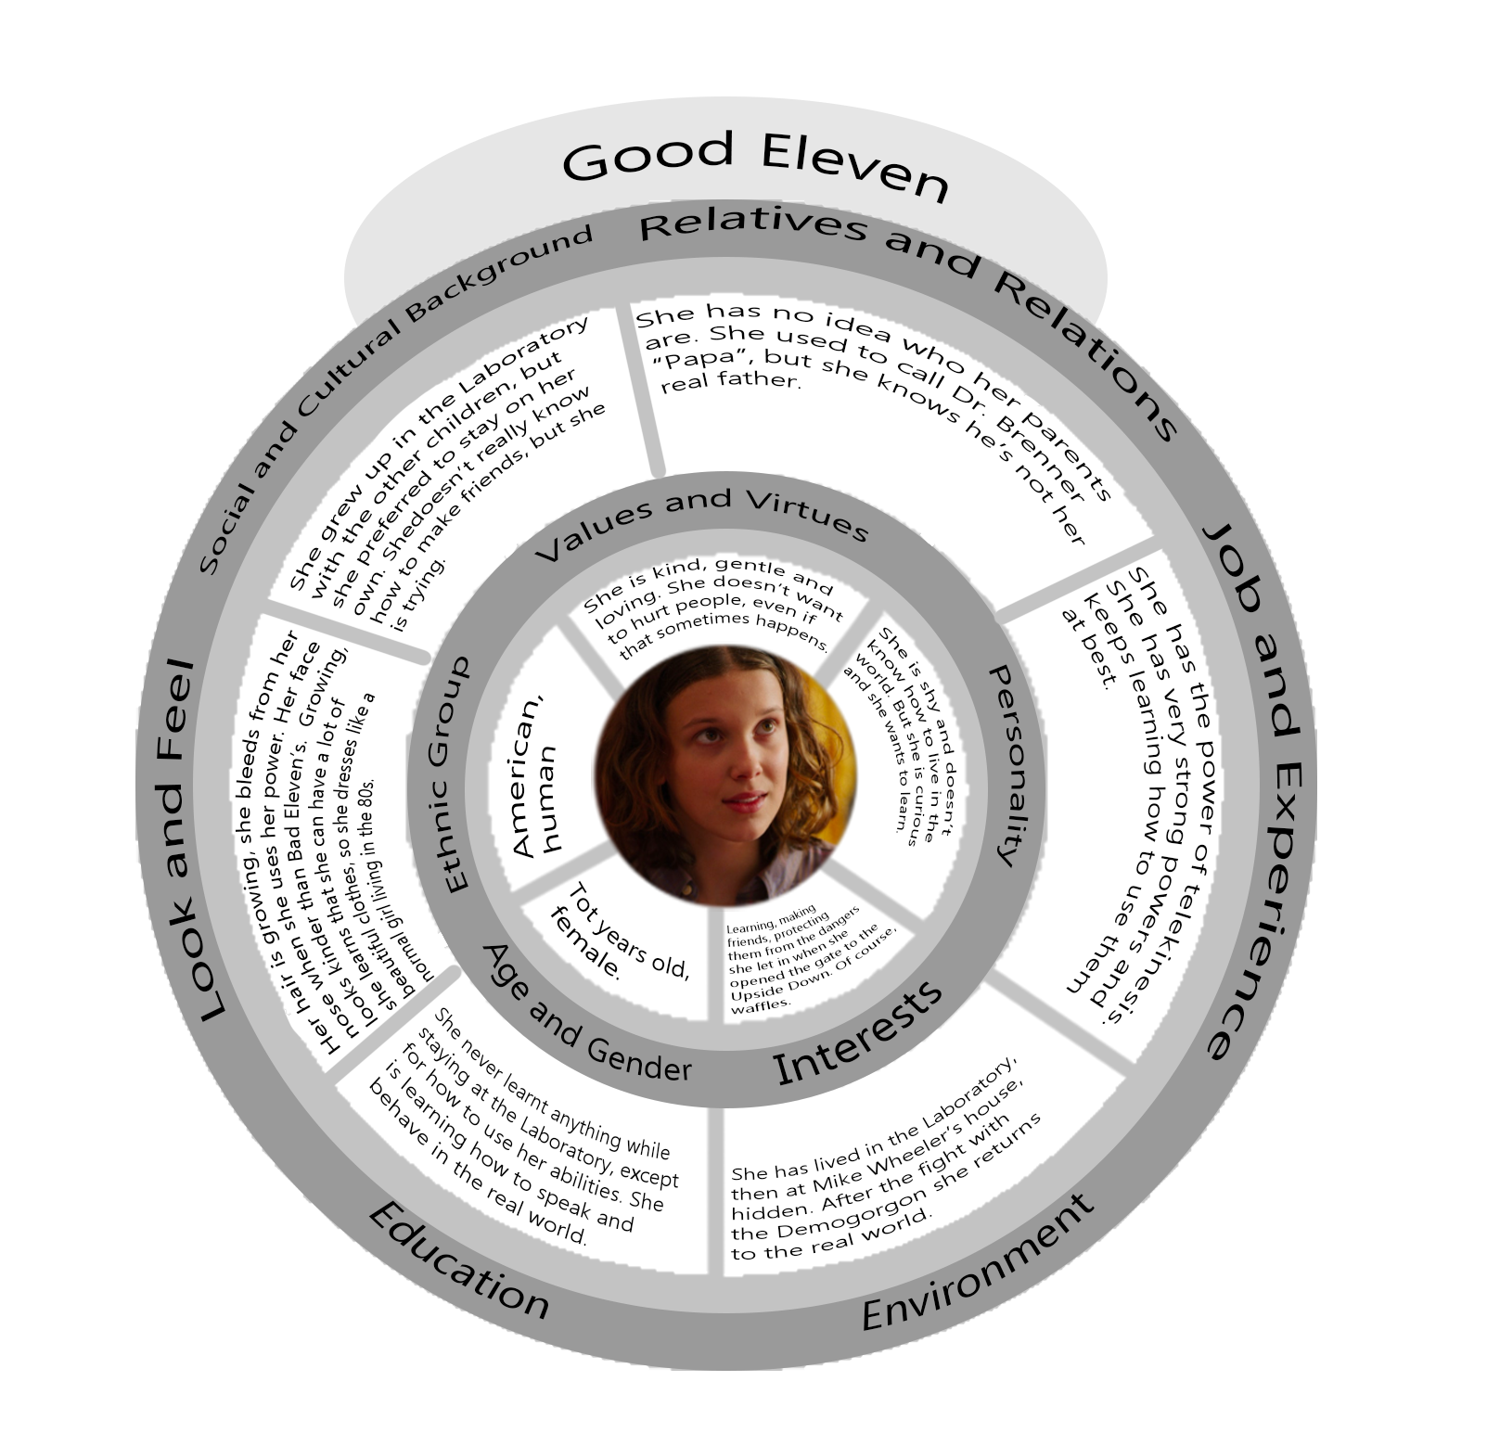

6.2.3. Map of the relations with the other characters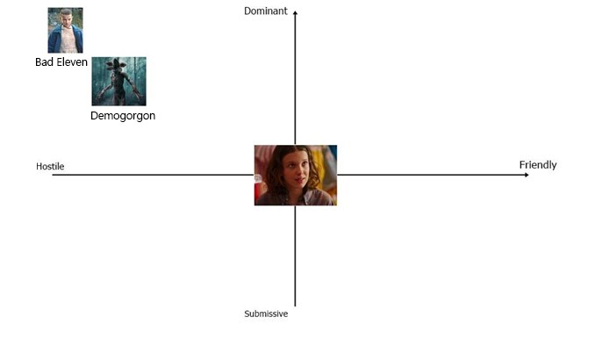

## 

## 6.3. Demogorgon

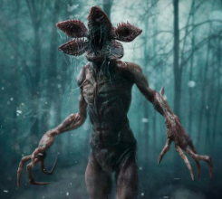

(Picture from Google Images)

6.3.1. Description

It is the main antagonist of the first season of the series. It lives in the Upside Down, and he is first seen in a vision Eleven has while in the Laboratory. As she touches it, the gate between the two worlds opens and it immediately crosses it to come to the real world. It is a human-like predator, attracted by the smell of blood that prefers to hunt at night. It is really tall and has long arms, with deadly claws. It is hostile towards all the children except Zasha, who can control its mind and lives in its Lair.

6.3.2. Circumplex

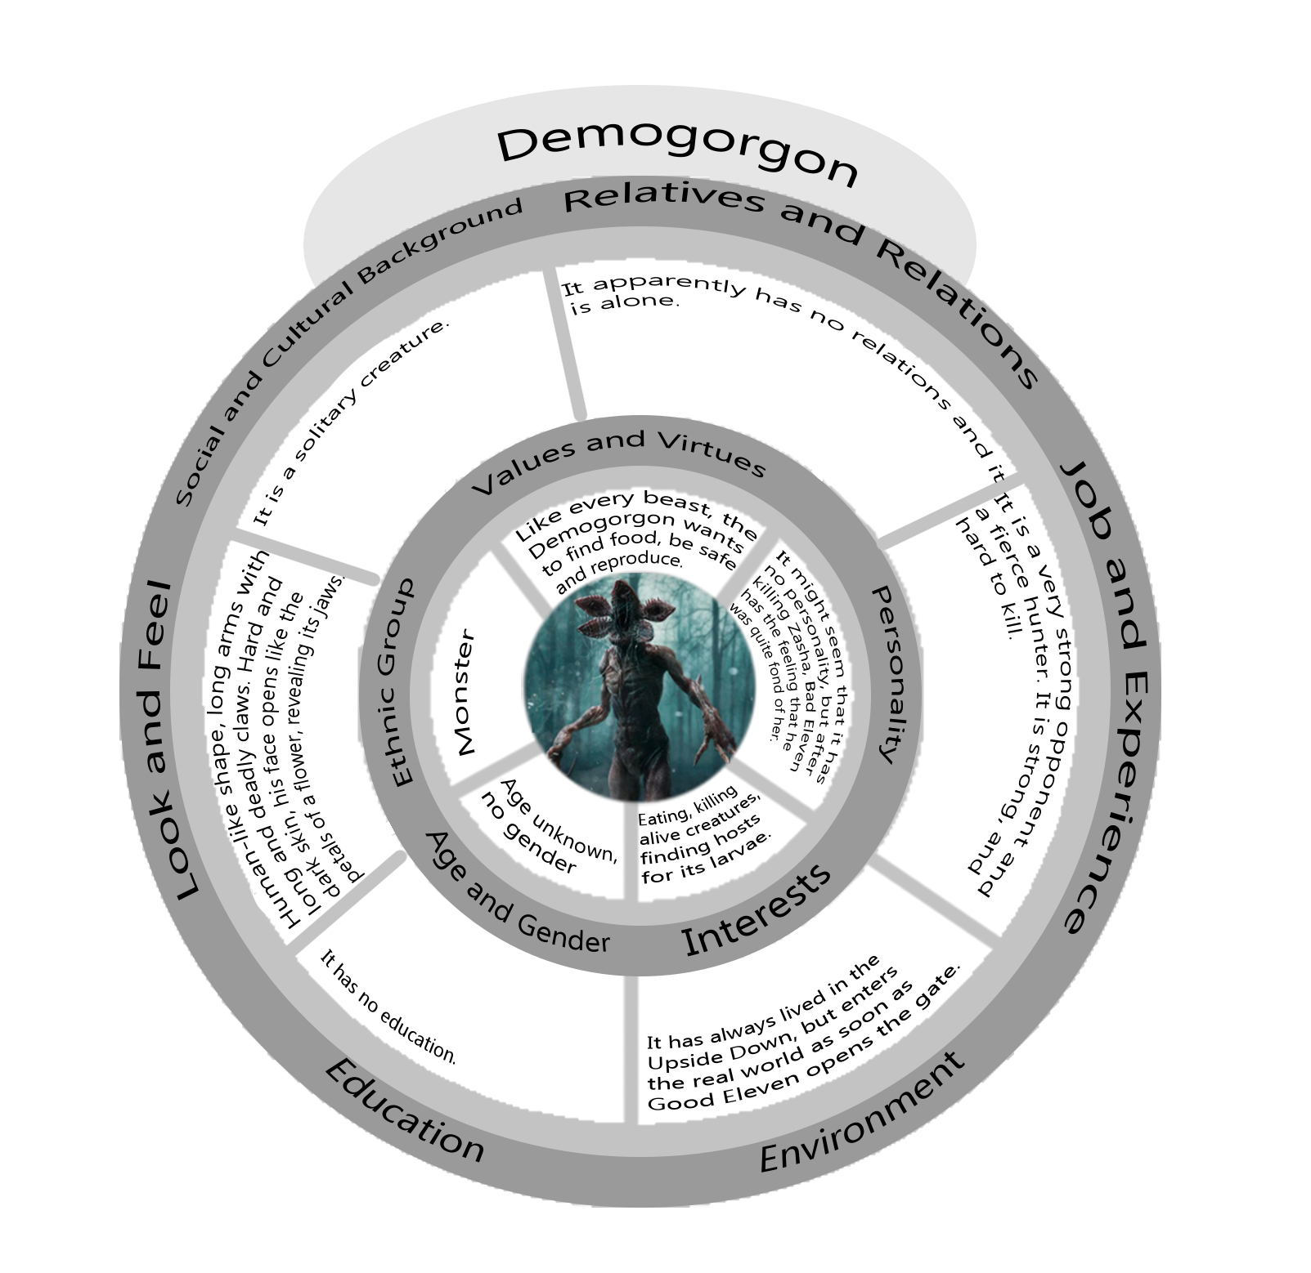

6.3.3. Map of the relations with the other characters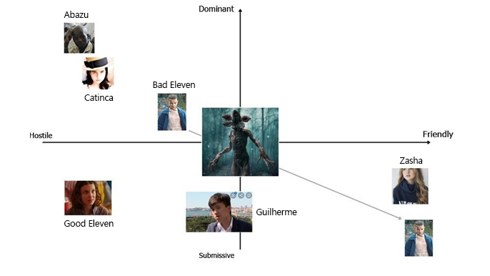

## 6.4. Kali Prasad (8)

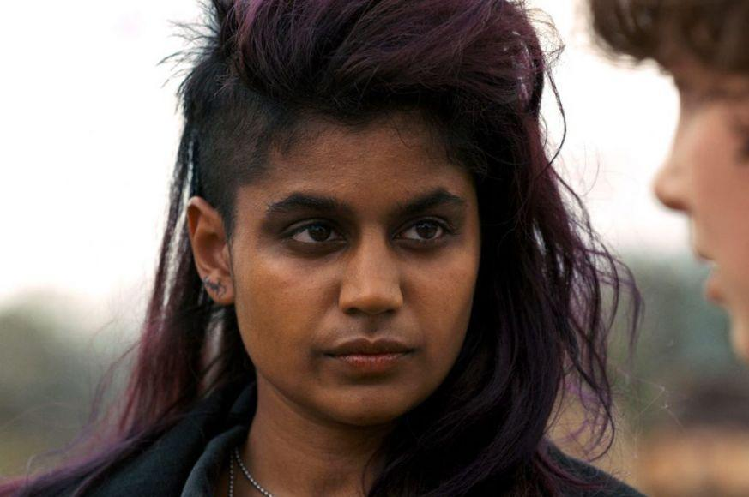

(Screenshot from Stranger Things)

6.4.1. Description

Kali is a young girl born in London, who lived in the Hawkins Laboratory with the other children. She is shown in the second season of the series. She has the ability of giving people illusions, making them see what she wants. She is angry at the people who hurt her and the other children, and spends her time hunting them down and killing them. The bad copy of Kali generated while she was still in the Laboratory and had to create a gigantic illusion. Her power is of no use to the player, but if she is unlocked (by opening the Rainbow Room) she will help the player see the memories of the other children instead of just hearing them in her head.

Her object is a drawing of her and Good Eleven together, that is hanging on the door of the Rainbow Room.

6.4.2. Circumplex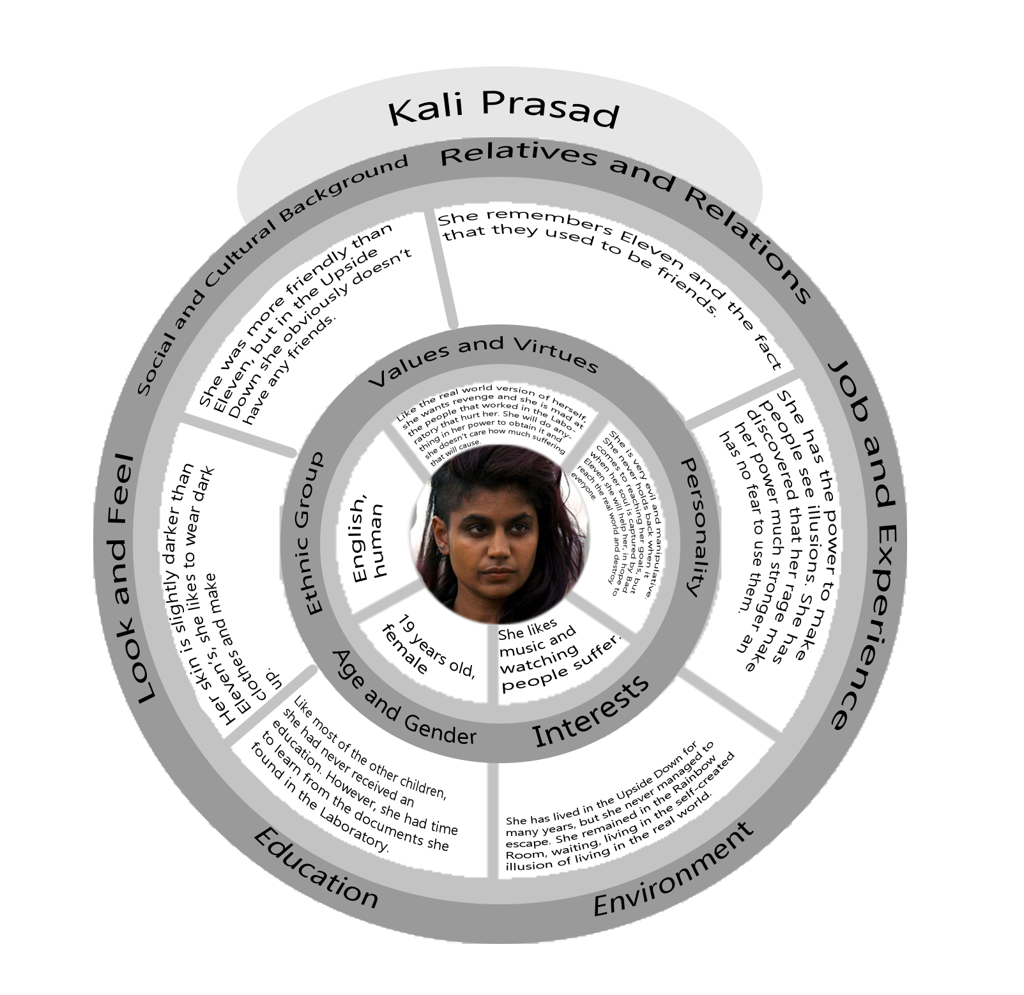

6.4.3. Map of the relations with other characters 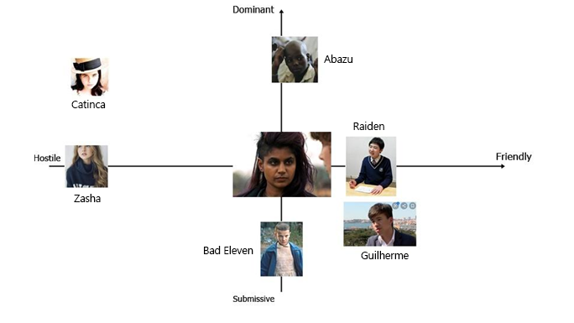

## 6.5. Raiden (1)

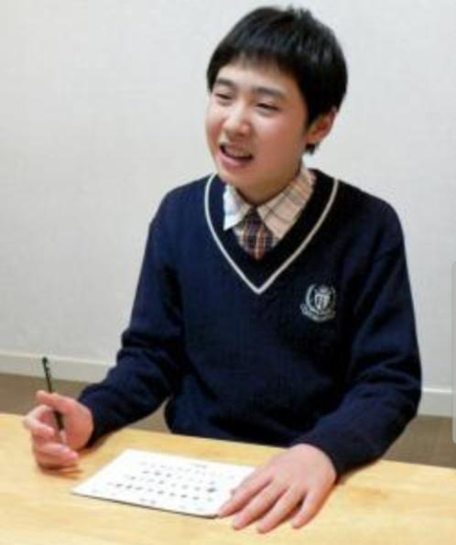

(Picture from Google Images)

### 6.5.1. Description

### He is the son of a woman who lived near Nagasaki when she was a young girl. As soon as he was born it was clear that he had super powers. He was taken away by the men of Dr. Brenner at a young age and never saw his family again. He has always been a very clever boy and he liked to study so much that Dr. Brenner gave him books as rewards when the experiments went well. He can run and move at incredible speeds. His bad copy generated after an experiment in which he had to crash against an iron surface and has lived in the Laboratory ever since. He has collected all the books he could find and he keeps them with him to read them over and over again. He is not interested in going back to the real world.

His object is the first coloring book that was given to him when he was little.

### 6.5.2. Circumplex

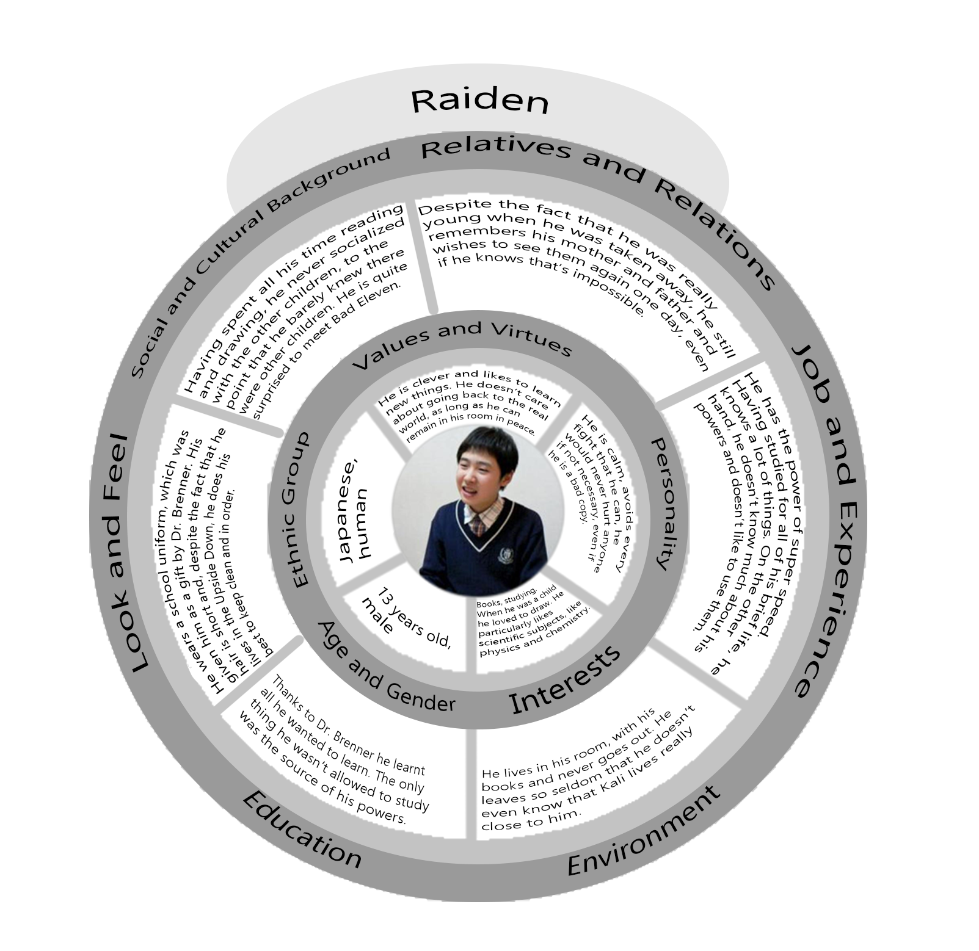

### 6.5.3. Map of the relations with other characters

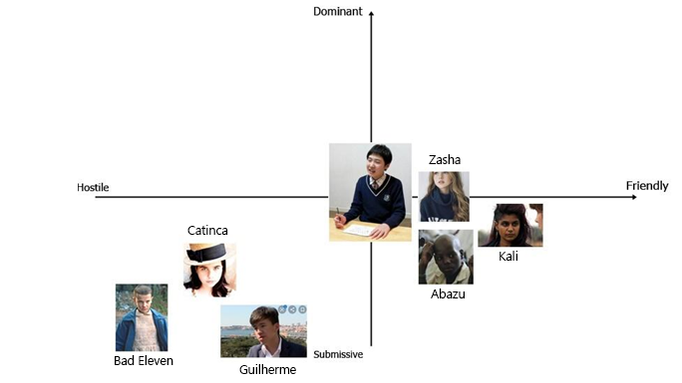

## 6.6. Guilherme (9)



(Picture from Google Images)

### 6.6.1. Description

Guilherme was born in Lisbon in 1972. His father was an abusive man aligned with the dictatorship and allowed his wife to be experimented on by the government. When Guilherme was born, he was taken away from her as another test subject and was only allowed to see his father. When the man found out that his son could control and generate fire, he had him isolated from the world in a special facility. He was found by Dr. Brenner and taken to Hawkins after the fall of the regime but he has been a difficult child to deal with ever since. The bad copy was generated when he tried to burn down the whole Hawkins Laboratory. In the Upside Down he likes to live in the woods and to explore. He is the only child who is not afraid to challenge the Demogorgon.

His object is a gun, which he found in the Laboratory and which he keeps as a reminder of what he believes his greatest success: his escape from the Laboratory.

6.6.2. Circumplex

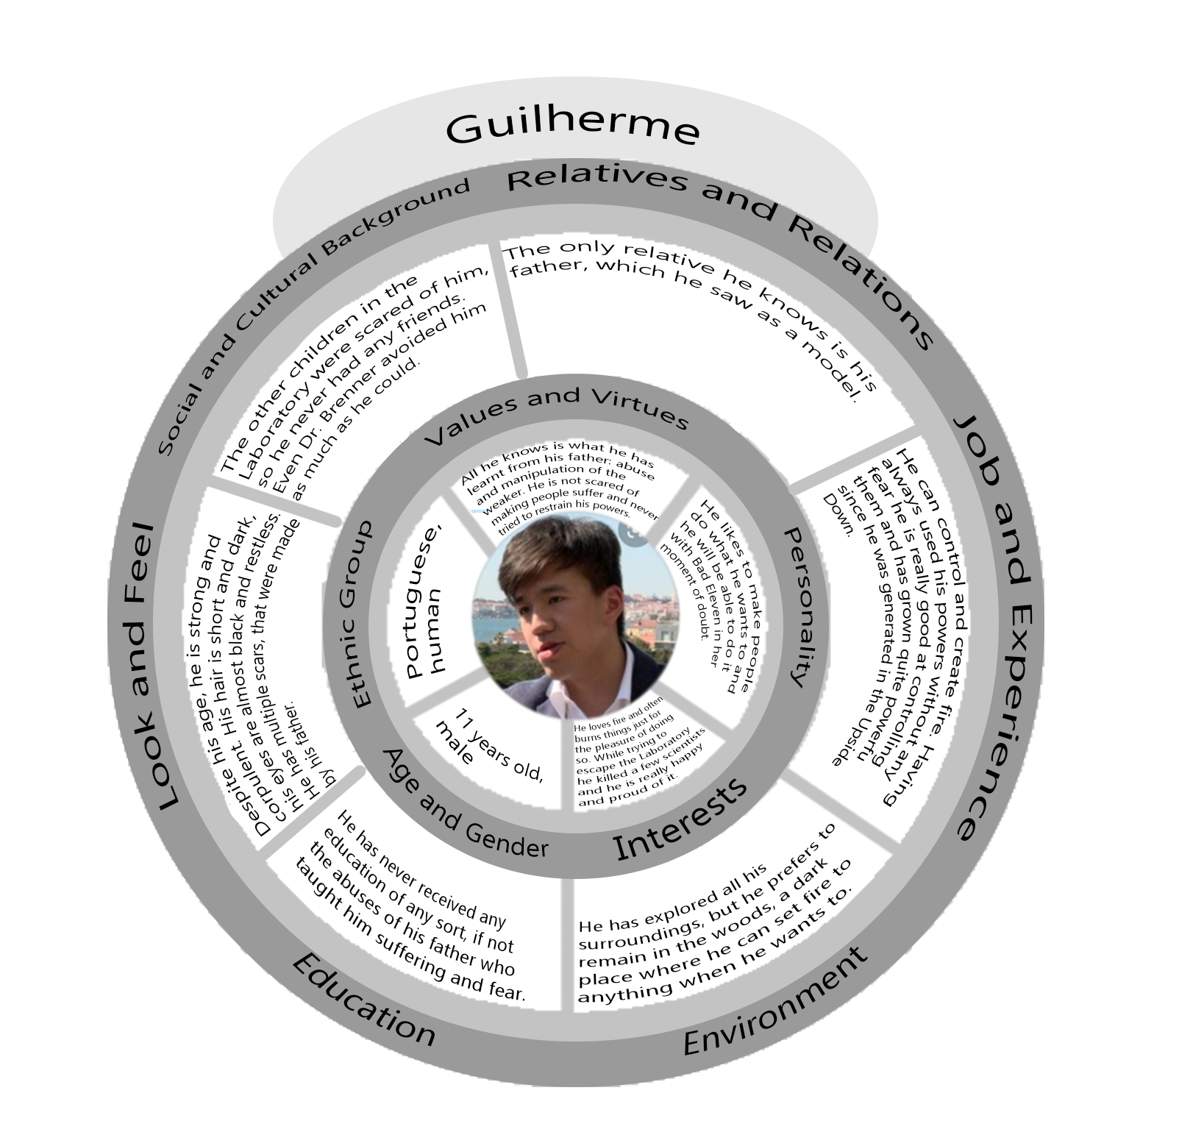

### 6.6.3. Map of the relations with other characters

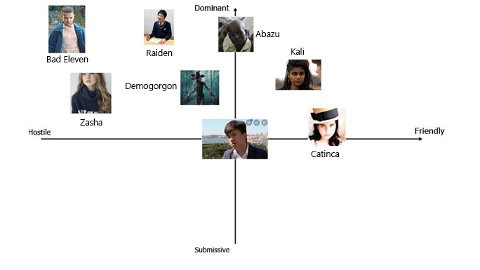

## 6.7. Catinca (3)



(Picture from Google Images)

### 6.7.1. Description

Catinca was born in Transylvania in 1972 in a family of farmers. Her parents soon found out that she had the power of levitation and of duplicating herself, and forced her to use them in order to help them in their job. Due to this, she never got a proper childhood and she soon became famous in her small village. People began to pay her parents to have her help them in their farms too and so she spent her early days like a slave. As word spread out, Dr. Brenner found her and kidnapped her. In the Laboratory, she often refused to do what she was asked to do. Her copy was generated after a bad fight with the other children. When she arrived to the Upside Down she ran away and found a shelter in the junkyard, but was soon surrounded by Demodogs and other monsters. She has remained there ever since.

Her object is an apple, which reminds her of her childhood and home.

6.7.2. Circumplex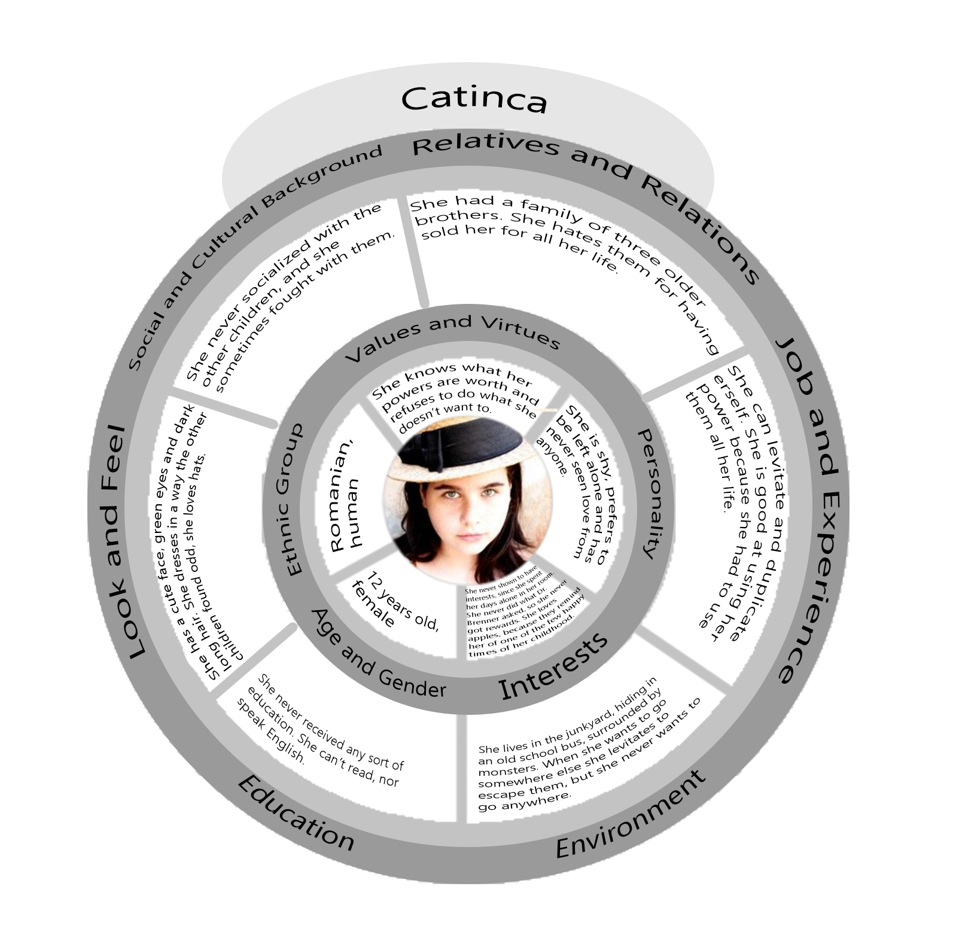

### 6.7.3. Map of the relations with other characters

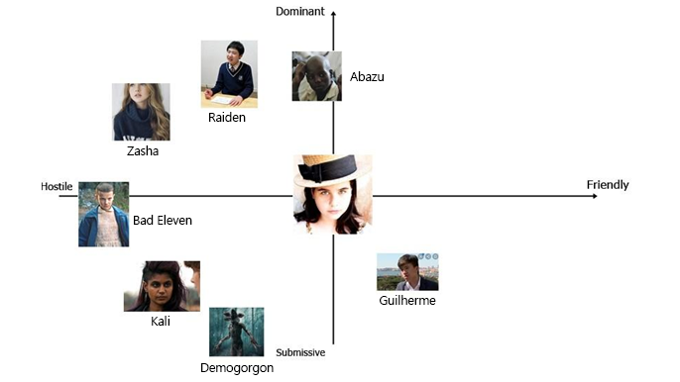

## 

## 6.8. Abazu (7)



(Picture from Google Images)

### 6.8.1. Description

He was born in Zimbabwe in 1968. He was born in a poor family that lived in a small village, but has lived happily for a few years before being found by Dr. Brenner. He offered money to his family to buy him and it was him who convinced them to do it, in order to help them. He missed them and wished to go back to them one day, but he knew he couldn’t escape the facility in which he was kept. Due to his powers, everyone liked him and he has easily become the favourite children of the scientists. He was still in the Laboratory when Good Eleven opened the gate and his bad copy was generated by his attempt of befriending the Demogorgon in order to save everyone else. While his bad copy lives on, the real Abazu died in the attempt. The copy is hidden in Will’s house, because he spied on Will while he was in the Upside Down but didn’t dare to face the Demogorgon again, when it came to take the boy.

His object is a pirate ship in a bottle, given him by Dr. Brenner.

6.8.2.Circumplex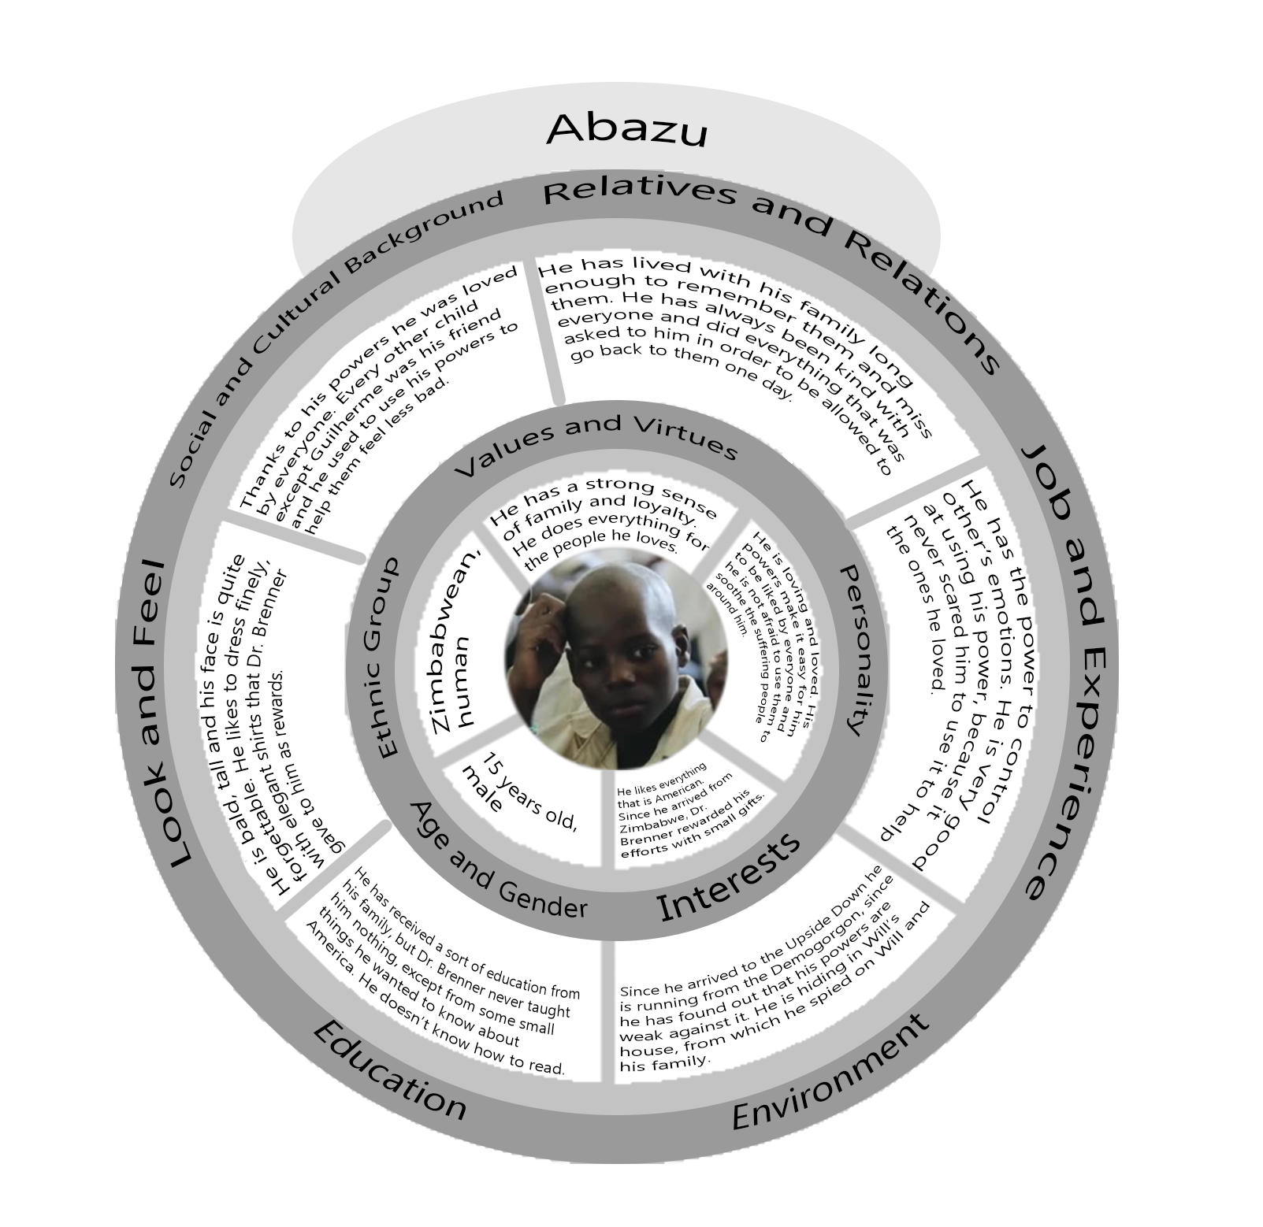

### 6.8.3. Map of the relations with other characters

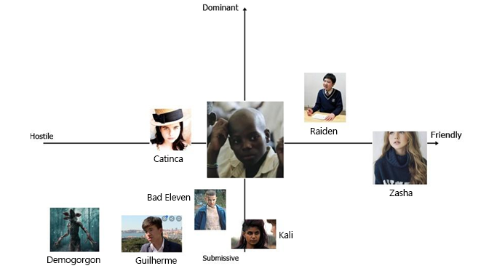

## 6.9. Zasha (5)



(Picture from Google Images)

### 6.9.1. Description

### Zasha was born in Russia in 1974. Her parents abandoned her in an orphanage when she was just a few days old. The nurses immediately understood there was something wrong with her and called the Russian intelligence. She became an experiment when she was two years old, but it took months before the scientist could figure out that she could control their minds. She underwent brainwash and was sent to America, in a way that Dr. Brenner could find her so she could control him. Something didn’t work out and she was imprisoned in Hawkins Laboratory, far from all the other children. She was tortured with electricity and was constantly drugged. The copy in the Upside Down was generated while she was trying to escape, failing. She doesn’t like the Upside Down, but she feels safe in the Demogorgon’s Lair, where she can control him to make him protect her.

Her object is a pendant with the pictures of her parents, the only thing from her childhood that she has been left with. She has lost it in the depths of the Lair and is scared to go back to look for it.

### 6.9.2. Circumplex

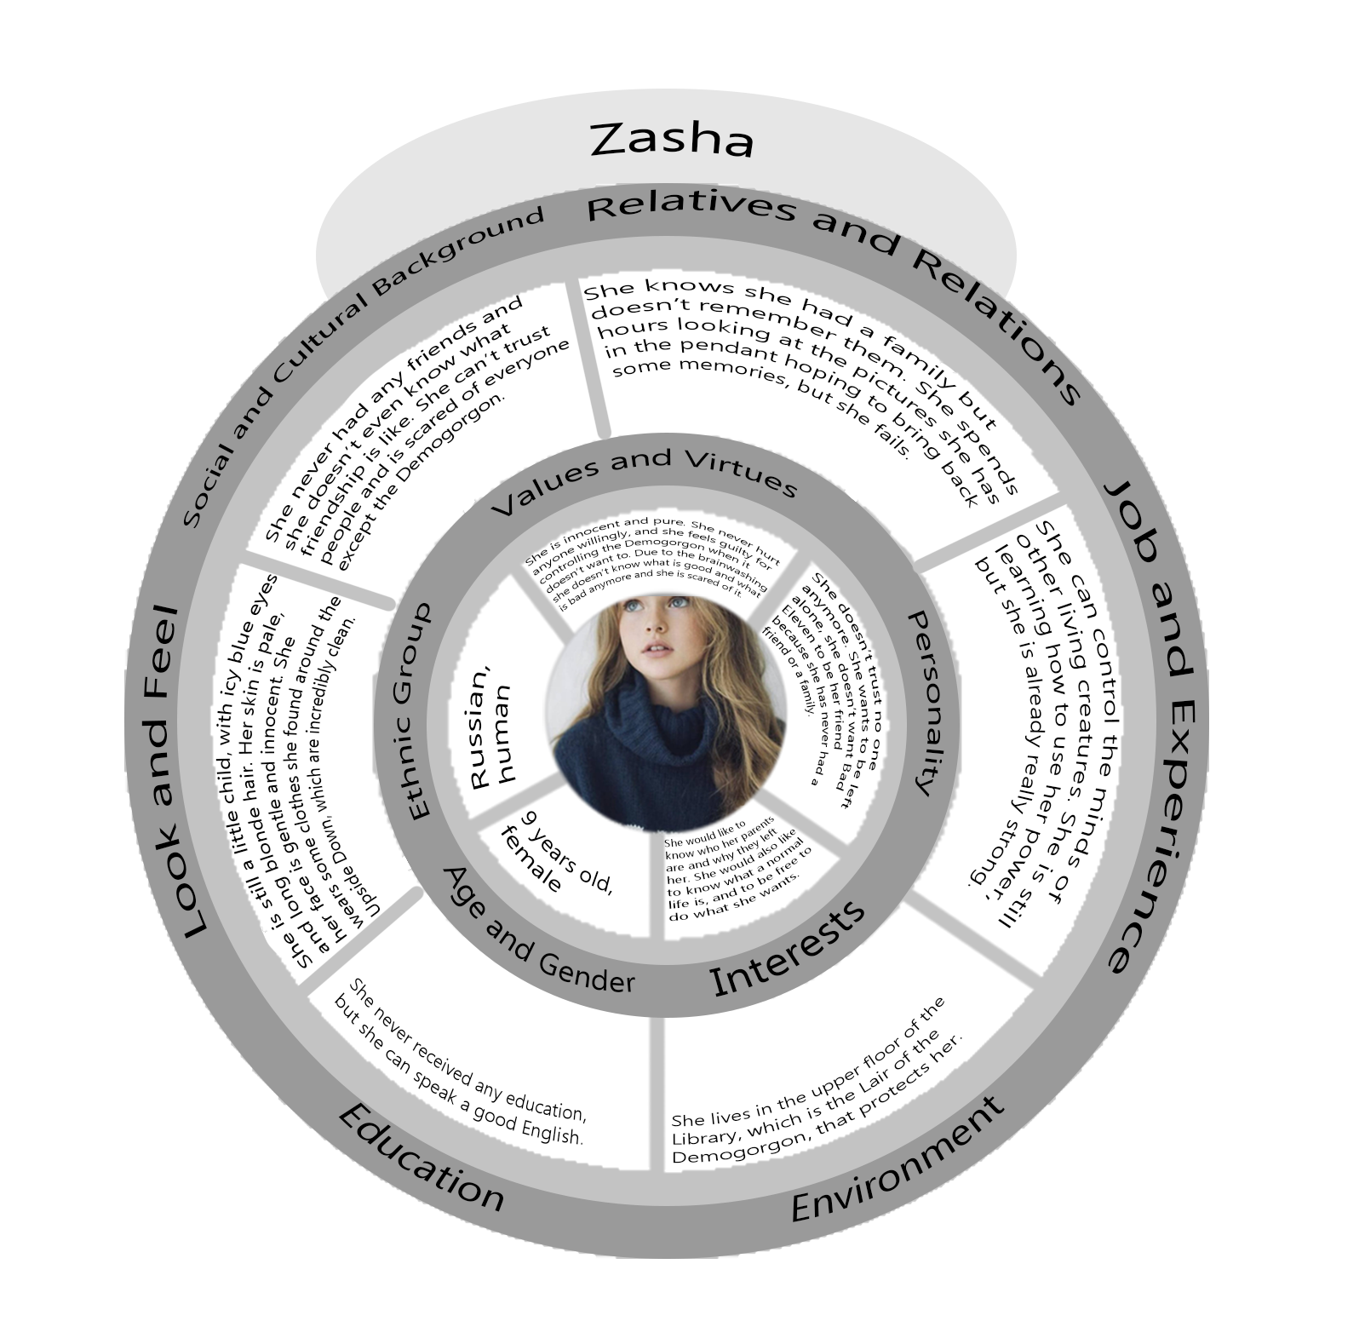

### 6.9.3. Map of the relations with other characters

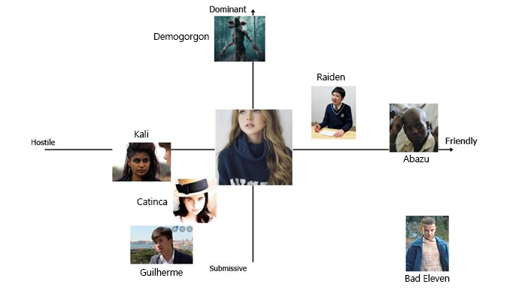

7. World Diagram

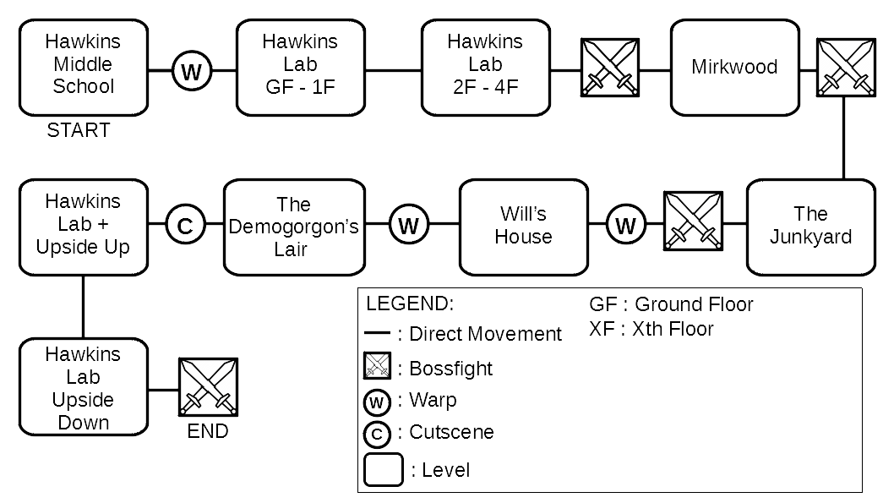

8. Goal Outline

# 8.1. Hawkins Middle School

* Explore the school (Tutorial movement & Powers & Items)
* Find the exit

# 8.2. Hawkins Laboratory, Upper floors

* Open the laboratory doors (puzzle)
* Floor 0
  + Explore the floor
  + Find the Elevator
  + Access the Elevator (puzzle)
  + Find the stairs
  + Go back to the Elevator
* Floor 1
  + Explore the floor
  + Visit the children rooms in order to get information about them
  + Find the stairs
  + Pick up Eleven’s Toy
  + Go back to the Elevator
* Floor 2
  + Explore the floor
  + Find the stairs
  + Open the door to access the stairs (puzzle)
* Floor 3
  + Explore the floor
  + Find Raiden’s toy in the office (puzzle)
  + Go back to the stairs
* Floor 4
  + Defeat Raiden (Miniboss)
  + Tutorial super-speed
* Exit the laboratory

8.3. Mirkwood

* Enter the woods
* Explore the area (puzzles)
* Find Guilherme’s toy in a hollow tree
* Find Guilherme
* Defeat Guilherme (using super speed)

# 8.4. The Junkyard

* Explore the area in a stealthy way.
* Find Catinca’s toy in a abandoned car
* Open the car (puzzles)
* Find Catinca (she is hiding on the bus)
* Defeat Catinca (using telekinesis & fireballs)

# 8.5. Will’s House and Castle Byers

* Frontyard
* Explore the area
* Spot Abazu in the living room
* Lure Abazu outside the house in order to find his toy first (light puzzle). It will probably be necessary to do this multiple times, as Abazu comes back after a while.
* Enter the house
* In the house
  + Search for Abazu’s toy
* Move to Castle Byers
* Castle Byers
  + Open Castle Byers door and enter in it (puzzle)
* Pick up Abazu’s toy
* Reach the garage
* Garage
* Open the door (puzzle)
* Pick up the Rifle
* Go back to the house where Abazu is
* Shoot Abazu
* Defeat the demo-creatures (emotional control tutorial)

# 8.6. The Demogorgon’s Lair

* Explore the area
* Find Zasha (puzzle)
* Use the emotional control power to manipulate and approach her
* Find Zasha’s pendant in the lower floors of the Lair
* Befriend Zasha
* Kill Zasha
* Escape the Demogorgon by controlling his mind

# 8.7. Real Hawkins

* Reach the gate in the Laboratory (using the Demogorgon)
* Pass the gate (failed)
* Pass the gate (using the Demogorgon)

Using the Demogorgon:

* Explore the area (puzzles)
* Find G11
* Fight and kill G11
* Escape and lure G11 in the Upside Down

# 8.8. Hawkins Laboratory, Lower floors

* BOSS FIGHT against G11
* Use the Demogorgon to defeat G11 once and for all
* END

9. Scope of the Game

|  |  |  |  |
| --- | --- | --- | --- |
| **Level** | **Estimated Time** | **Percentage** | **Difficulty** |
| Hawkins Middle School | 15 min | 3.8 % | Tutorial |
| Hawkins Laboratory, Upper floors | 60 min | 15.6 % | Easy |
| Mirkwood | 45 min | 11.7 % | Easy / Medium |
| The Junkyard | 45 min | 11.7 % | Medium |
| Will’s House and Castle Byers | 60 min | 15.6 % | Medium |
| The Demogorgon’s Lair | 100 min | 26 % | Hard |
| Real Hawkins | 30 min | 7.8 % | Medium |
| Hawkins Laboratory, Lower floors | 30 min | 7.8 % | Hard |
| TOTAL | 385 m | 100 % |  |

The estimations are done including the cutscenes.

The percentages are approximated using the scientific approximation.

|  |  |
| --- | --- |
| Difficulty | Description |
| **Tutorial** | No skills are required. This mode is meant to teach the player some game mechanism/in-game power in a safe environment. |
| **Easy** | In this mode there are low level puzzle and weak opponent in which the player can test and practice their skills. |
| **Medium** | The player is required to use their powers to solve puzzles or defeat the enemies in order to master their skills. |
| **Hard** | This mode is characterized by strong opponents that have to be dealt with while puzzle solving. The player is required to be confident with the game controls and their powers. |

10. Enemies Chart

|  |  |  |  |  |
| --- | --- | --- | --- | --- |
| Enemies /  Level | Puppy demodog | Demodog | Burly demodog | Demogorgon* |
| Hawkins Middle School | X |  |  |  |
| Hawkins Laboratory, Upper floors |  | X |  |  |
| Mirkwood | X | X |  |  |
| The Junkyard |  | X |  |  |
| Will’s House and Castle Byers |  |  |  |  |
| The Demogorgon’s Lair | X | X | X | X |
| Real Hawkins |  |  |  |  |
| Hawkins Laboratory, Lower floors |  | X | X |  |

* It is present as a special type of enemy only in level 6 - The Demogorgon’s Lair (see section 13.5).

11. Skill Chart

|  |  |  |  |  |  |  |
| --- | --- | --- | --- | --- | --- | --- |
| Skill /  Level | Telekinesis | Expanded mind | Super speed | Fire ball | Levitation | Emotion control |
| Hawkins Middle School | X | O |  |  |  |  |
| Hawkins Laboratory, Upper floors | X | O |  |  |  |  |
| Mirkwood | X | O | X |  |  |  |
| The Junkyard | X | O |  | X |  |  |
| Will’s House and Castle Byers | X | O | X |  | X |  |
| The Demogorgon’s Lair | X | O | X | X | X | X |
| Real Hawkins |  |  |  |  |  |  |
| Hawkins Laboratory, Lower floors | X | O | X | X | X | O |

**X**: indicates that a skill is required.

**O**: indicates that a skill is optional, that is, the player can arbitrarily choose to use it or not.

12. Gameplay elements and Additional mechanics

This section features some additional mechanics and gameplay elements which act as an extension and an adjustment of the rules of Dungeons & Dragons (fifth edition) to the videogame medium.

## 12.1. Bad Eleven’s health and power bar

Bad Eleven’s health bar is not directly visible on the HUD, since it is hidden. When she takes damage, the screen will start to provide visual feedback, in terms of bloodstains at the corners of the screen and a progressive color desaturation (that is, the screen becomes more and more grey). When she stops receiving damage for a short amount of time (about 5 seconds), health will start regenerating automatically, at a rate of 10% of the total health per second. As the health regenerates, the screen will return to its original state accordingly.

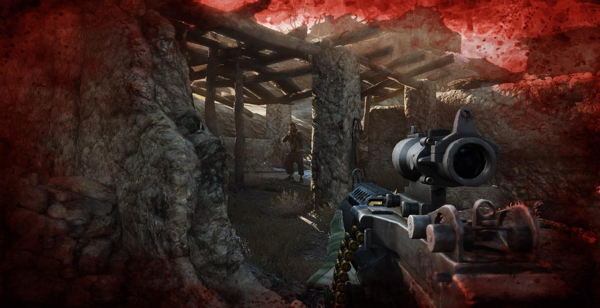

(Picture from *Medal of Honor*, found on Google Images)

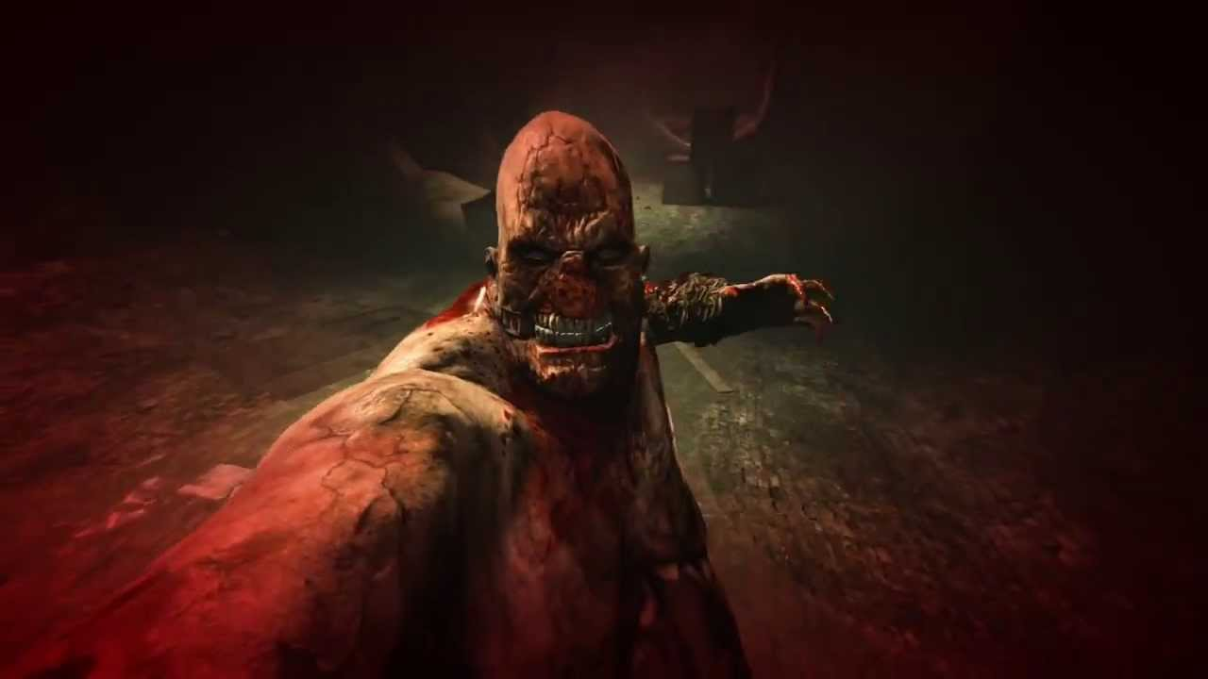

(Picture from *Outlast*, found on Google Images)

Bad Eleven powers share a common power bar, which depletes every time a power is used, of an amount dependent on the power used and the usage time. Unlike the health bar, the power bar does not regenerate automatically, and specific items are required in order to restore it. When the power bar is empty or there is not enough of it to use any power and Bad Eleven tries to use any one of them, instead of the standard animation of the used power, a special animation will trigger, where Bad Eleven tries to use a power but fails, moaning for the strain. If B11 uses a big amount of power another animation will trigger of her wiping away the blood from her nose.

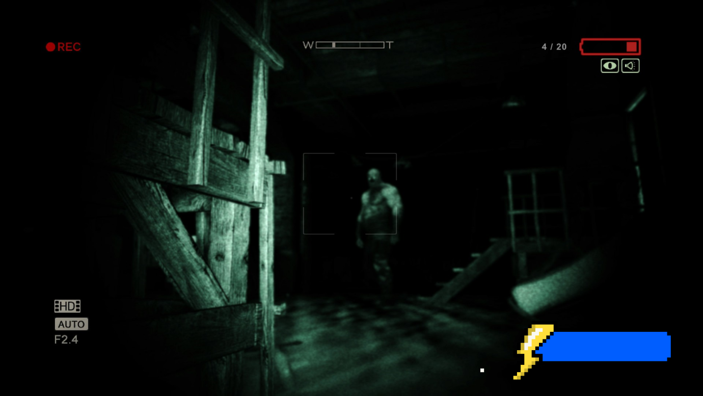

(Picture from *Outlast*, found on Google Images and edited)

## 12.2. Checkpoints and game saves

The game automatically saves every time a goal (or sub-goal) is reached, an item is picked up and, in general, every time the player makes any kind of progression in the game. However, there are some exceptions: during a boss encounter or a combat the game does not save, and the only way to make the game save is to overcome such obstacles. When Bad Eleven dies or the player quits the game, the game will restart by the most recent save file.

## 12.3. Items

### 12.3.1. Consumable items

Whenever Bad Eleven picks up a consumable item, it will be automatically added to her inventory. Every consumable item she possesses can be directly selected and used in game without opening any menu.

|  |  |  |  |
| --- | --- | --- | --- |
| Image | Name | Description | Effect |
|  | Small waffle | Small waffle. It restores a small amount of power. | Restores 25% of the power bar. |
|  | Medium waffle | Medium waffle. It restores a good amount of power. | Restores 50% of the power bar. |
|  | Large waffle | Large waffle. It restores a great amount of power. | Restores 75% of the power bar. |
|  | Peanut-butter waffle | Waffle covered by delicious peanut butter. It restores a huge amount of power. | Restores 100% of the power bar. |

### 12.3.2. Collectible items

|  |  |  |  |
| --- | --- | --- | --- |
| Image | Name | Description | Effect |
|  | Lantern | Lanter found in Hawkins Library, which emits a feeble light. It can be used to light up dark areas. | It illuminates the player’s surroundings, and its effect will last as long as they decide to keep it lit. |
|  | Intel | Intel regarding the experiments on the kids. | They provide the player information about the other kids (appearance, powers, skills, capabilities) |
|  | Memory Crystal | A crystal that contain a piece of memory. | Shows the player a piece of memory belonging to one of the kids (it is only an audio if Kali is not unlocked - see section 6.4.1). |

Intel are mainly found in the Laboratory, and they include pictures, documents and articles regarding the other kids; they offer precious information about them, starting from their appearance, to their powers, skills, capabilities; moreover, they also provide knowledge about their past, their attitude and behavior. While some of them are mandatory in order to find and kill each one of them, others (especially those that provide an insight of their backstory and general attitude) are optional, and only serve the purpose to supply extra information about the world and story.

13. Character and Enemies sheets

## 13.1. Introductory notes

* A round represents about three seconds in the real time gameplay;
* Each turn a character or an enemy can move a distance up to its speed and take one action from the list in its own sheet;
* Every attack performed by a character or an enemy matches a melee or a ranged attack present in the rules of D&D, although they have been properly adjusted in terms of damage and range in order to fit the game areas and keep the game balanced.

Moreover, the following abbreviations will be used in the next sections:

* **dx**, where x is an even number less or equal to 20: a die with x sides;
* **AC**: Armor Class. The higher this value is, the harder it is to hit the character or the enemy;
* **HP**: Hit Points, they represent the character or enemy durability. When they drop down to 0, the character or enemy die.
* **PP**: Power Points, they are consumed whenever Bad Eleven uses a power;
* **ST**: Saving Throw, the attempt to reduce or avoid a negative effect, like a spell. It is performed by rolling a d20;
* **Save DC**: Difficulty Class of a saving throw. When a spell allows a saving throw, its difficulty class is determined by the caster’s spellcasting ability. This value needs to be compared to the spell target’s roll in order to determine the result of the saving throw.

## 13.2. Bad Eleven

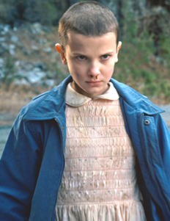

13.2.1. Description

Bad Eleven uses her own powers and the ones she got from the other children she faced so far to advance in the game, solve puzzles and fight against enemies. She doesn’t possess any kind of weapon, since she can use her powers from distance; however, every usage of a power consumes power points, which are subtracted from her power bar. Regardless of the power bar is depleted or not, she can also rely on her bare fists as an improvised melee weapon.

13.2.2. Statistics

**HP**: 30

**PP**: 100

**Class**: Wizard

**AC**: 10 = 10 (no armor) + 0 (Dexterity modifier)

**Proficiency bonus**: +2

**Spellcasting ability**: Charisma

**Save DC**: 13 = 8 (base value) + 3 (spellcasting ability modifier) + 2 (proficiency bonus)

**Speed**: 5 m per turn

|  |  |  |  |  |  |  |
| --- | --- | --- | --- | --- | --- | --- |
| Ability name | Strength | Dexterity | Constitution | Intelligence | Wisdom | Charisma |
| Ability value | 9 | 11 | 15 | 13 | 14 | 16 |
| Modifier | -1 | 0 | +2 | +1 | +2 | +3 |

13.2.3. Movements

* Vertical jump: 0.5 m;
* Horizontal jump: 0.5 m (base), 1 m (long).

13.2.4. Powers

* **Telekinesis**: Bad Eleven can use this power to move objects and to harm enemies by flinging them onto any surface (available from the beginning of the game);
* **Expanded mind**: Bad Eleven enlarge her senses, in order to see nearby enemies (available from the beginning of the game);
* **Super speed**; Bad Eleven can move at incredible speed, allowing her to cover great distances in little time, escape from enemies or dodge attacks (available after defeating Raiden);
* **Fire control**: Bad Eleven can cast fire balls to burn roots or harm enemies (available after defeating Guilherme);
* **Levitation**: Bad Eleven can lift herself in midair, allowing her to reach points otherwise out of reach or escape from enemies (available after defeating Catinca);
* **Emotion control**: Bad Eleven can control emotions, allowing her to ingratiate herself with enemies (available after defeating Abazu).

13.2.5. Skill details

|  |
| --- |
| **Bare fists**  Type: Melee  Range: 1 m  Damage: 2 = 1 (base value) – 1 (Strength modifier) + 2 (proficiency bonus)  Average damage: 2 |
| **Telekinesis**  Type: Ranged  Range: 3 m  Target: single  Damage: 1d6 + 3  Average damage: 6.5  PP: 5 per usage  When used on an object, it consumes 1 PP per second. |
| **Expanded mind**  Range: 4 m  PP: 2 per second |
| **Super speed**  Horizontal distance covered: 2 m  PP: 2 per usage  It can be used during a jump. |
| **Fire ball**  Type: Ranged  Range: 5 m  Target: single  Damage: 3d6 + 3  Average damage: 13.5  PP: 10 per usage  Damage reduced to half on successful ST. |
| **Levitation**  Max height reachable: 1.5 m  PP: 1 per second below or at 1 m, 2 per second above 1 m  It can be used during a jump. While midair, Bad Eleven can move as she was on the ground, with the advantage that she does not produce any noise, but on the other hand she cannot perform jumps. Moreover, during levitation she is able to use any other power. |
| **Emotion control**  Type: Ranged  Range: 4 m  Target: everyone in a 3 m radius  PP: 10 per usage    When used on enemies, it lasts until something harmful is done to them. |

## 13.2. Demodog

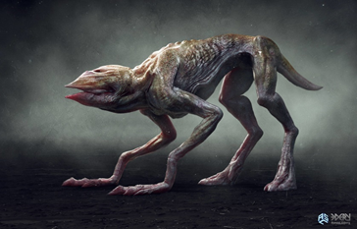

13.3.1. Description

Predatory creature originated from the Upside Down. Although it has the size of a large dog, it is strong enough to kill an adult human. It has a sharp hearing and smell, and the capability to climb steep surfaces and dig tunnels. It usually moves in packs, although it is possible to encounter some solitary specimen.

13.3.2. Statistics

**HP**: 12

**AC**: 13

**Speed**: 12 m per turn

|  |  |  |  |  |  |  |
| --- | --- | --- | --- | --- | --- | --- |
| Ability name | Strength | Dexterity | Constitution | Intelligence | Wisdom | Charisma |
| Ability value | 12 | 15 | 12 | 3 | 12 | 6 |
| Modifier | +1 | +2 | +1 | -4 | +1 | -2 |

13.3.3. Actions

|  |
| --- |
| **Bite**  Type: Melee  Range: 1 m  Target: single  Damage: 2d4 + 2  Average damage: 7 |

Damage dealt on Bad Eleven

|  |  |  |  |
| --- | --- | --- | --- |
| Action | Average damage | Hit Chance (AC 10) | Damage dealt per round |
| Bite | 7 | 0.5 (10/20) | 3.5 (7 x 0.5) |

Bad Eleven has 30 HP, which means that she requires 5 hits (30 / 7 = 4.286) in order to be killed. A demodog needs 9 rounds (30 / 3.5 = 8.571) to defeat Bad Eleven.

Damage taken from Bad Eleven

|  |  |  |  |
| --- | --- | --- | --- |
| Skill | Average damage | Hit Chance (AC 13) | Damage taken per round |
| Telekinesis | 6.5 | 0.35 (7/20) | 2.275 (6.5 x 0.35) |
| Fire ball  (failed ST = 13/20 successful ST = 7/20) | 13.5 (half on successful ST) | 0.35 (7/20) | 3.898 = 3.071 + 0.827 (13.5 x 0.35 x 0.65 + 6.75 x 0.35 x 0.35) |

A demodog has 12 HP, which means that it requires 2 telekinesis hits (12 / 6.5 = 1.846) or 1 fire ball hit (12 / 13.5 = 0.889) in order to be killed. Bad Eleven needs 6 rounds (12 / 2.275 = 5.274) using telekinesis and 4 rounds (12 / 3.898 = 3.079) using fireball to defeat a demodog.

## 13.4. Puppy Demodog

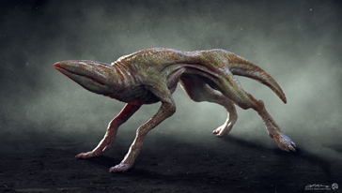

13.4.1. Description

Puppy of a demodog. It has the size of a cat and, although is not as strong as its adult counterpart, it’s still pretty aggressive.

13.4.2. Statistics

**HP**: 6

**AC**: 13

**Speed**: 12 m per turn

|  |  |  |  |  |  |  |
| --- | --- | --- | --- | --- | --- | --- |
| Ability name | Strength | Dexterity | Constitution | Intelligence | Wisdom | Charisma |
| Ability value | 12 | 15 | 12 | 3 | 12 | 6 |
| Modifier | +1 | +2 | +1 | -4 | +1 | -2 |

13.4.3. Actions

|  |
| --- |
| **Bite**  Type: Melee  Range: 1 m  Target: single  Damage: 2d2 + 2  Average damage: 5 |

Damage dealt on Bad Eleven

|  |  |  |  |
| --- | --- | --- | --- |
| Action | Average damage | Hit Chance (AC 10) | Damage dealt per round |
| Bite | 5 | 0.5 (10/20) | 2.5 (5 x 0.5) |

Bad Eleven has 30 HP, which means that she requires 6 hits (30 / 5 = 6) in order to be killed. A puppy demodog needs 12 rounds (30 / 2.5 = 12) to defeat Bad Eleven.

Damage taken from Bad Eleven

|  |  |  |  |
| --- | --- | --- | --- |
| Skill | Average damage | Hit Chance (AC 13) | Damage taken per round |
| Telekinesis | 6.5 | 0.35 (7/20) | 2.275 (6.5 x 0.35) |

A puppy demodog has 6 HP, which means that it requires 1 telekinesis hit (6 / 6.5 = 0.923) in order to be killed. Bad Eleven needs 3 rounds (6 / 2.275 = 2.637) using telekinesis to defeat a puppy demodog.

## 13.5. Burly Demodog

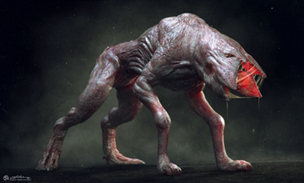

13.5.1. Description

Bulkier specimen of a demodog. Beyond its size, which is greater than the one of a normal demodog, its dangerousness derives from its improved resistance and strength.

13.5.2. Statistics

**HP**: 18

**AC**: 13

**Speed**: 12 m per turn

|  |  |  |  |  |  |  |
| --- | --- | --- | --- | --- | --- | --- |
| Ability name | Strength | Dexterity | Constitution | Intelligence | Wisdom | Charisma |
| Ability value | 12 | 15 | 12 | 3 | 12 | 6 |
| Modifier | +1 | +2 | +1 | -4 | +1 | -2 |

13.5.3. Actions

|  |
| --- |
| **Bite**  Type: Melee  Range: 1 m  Target: single  Damage: 2d6 + 2  Average damage: 9 |

Damage dealt on Bad Eleven

|  |  |  |  |
| --- | --- | --- | --- |
| Action | Average damage | Hit Chance (AC 10) | Damage dealt per round |
| Bite | 9 | 0.5 (10/20) | 4.5 (9 x 0.5) |

Bad Eleven has 30 HP, which means that she requires 4 hits (30 / 9 = 3.333) in order to be killed. A burly demodog needs 7 rounds (30 / 4.5 = 6.666) to defeat Bad Eleven.

Damage taken from Bad Eleven

|  |  |  |  |
| --- | --- | --- | --- |
| Skill | Average damage | Hit Chance (AC 13) | Damage taken per round |
| Telekinesis | 6.5 | 0.35 (7/20) | 2.275 (6.5 x 0.35) |
| Fire ball  (failed ST = 13/20 successful ST = 7/20) | 13.5 (half on successful ST) | 0.35 (7/20) | 3.898 = 3.071 + 0.827 (13.5 x 0.35 x 0.65 + 6.75 x 0.35 x 0.35) |

A burly demodog has 18 HP, which means that it requires 3 telekinesis hits (18 / 6.5 = 2.769) or 2 fire ball hits (18 / 13.5 = 1.333) in order to be killed. Bad Eleven needs 8 rounds (18 / 2.275 = 7.912) using telekinesis and 5 rounds (18 / 3.898 = 4.618) using fireball to defeat a burly demodog.

## 13.6. Demogorgon

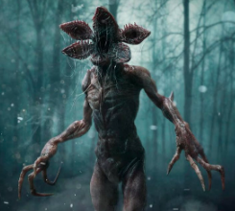

13.6.1. Description

Human-like predator, originated from the Upside Down. It is very tall and strong, capable of killing an adult human with no effort. It has an extremely evolved sense of smell, such that it is able to perceive a very little amount of blood even if it finds itself in another dimension. It’s a solitary creature, and prefers to hunt at night.

13.6.2. Statistics

**HP**: 60

**AC**: 15

**Speed**: 9 m per turn

|  |  |  |  |  |  |  |
| --- | --- | --- | --- | --- | --- | --- |
| Ability name | Strength | Dexterity | Constitution | Intelligence | Wisdom | Charisma |
| Ability value | 16 | 12 | 16 | 3 | 12 | 5 |
| Modifier | +3 | +1 | +3 | -4 | +1 | -3 |

13.6.3. Actions

|  |
| --- |
| **Bite**    Type: Melee  Range: 1 m  Target: single  Damage: 1d8 + 3  Average damage: 7.5 |
| **Claw**    Type: Melee  Range: 1 m  Target: single  Damage: 2d8 + 3  Average damage: 12 |

13.6.4. Finite state machine

The Demogorgon constantly chases Bad Eleven in the maze (floor -3, see section 14.3.5). It cannot be fought nor killed, and it will instantly kill Bad Eleven if it catches her.

At the very end of the level, it becomes a friendly creature, during the final cutscene that ends the level (see section 14.1).

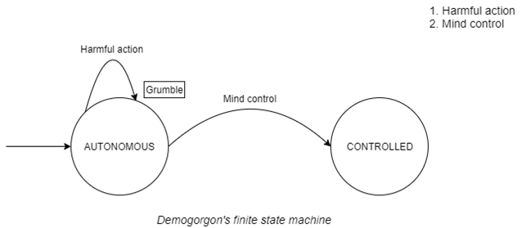

The Demogorgon cannot be killed while in autonomous state, and limits itself to follow Bad Eleven, doing nothing. While in controlled state, the player directly takes control on it; however, it is not possible to enter this state at will. The player will directly control the Demogorgon instead of B11 in the final cutscene of level 6 – The Demogorgon’s Lair, during the whole level 7 – Real Hawkins and in the final cutscene in which B11 dies. Besides these parts, after being controlled for the first time at the end of level 6 – The Demogorgon’s Lair, the Demogorgon will always follow B11 in autonomous state.

## 13.7. Sample encounters

In this section some examples of battles will be presented in order to provide a simulation of possible encounters a player will be confronted with. The difficulty of such battles will be directly proportional to the number of enemies in each encounter and to their strength and resilience. Moreover, all D&D rules regarding actions related to movements will be ignored since all of them will be performed in real time, as well as the rules related to disadvantages for ranged attacks performed below a certain distance.

13.7.1. Example of easy encounter

Enemies: 1 puppy demodog (PD), 1 demodog (DD)

B11: 30 HP, Telekinesis (1d6 + 3), Fire ball (3d6 + 3, half on successful ST)

PD: 6 HP, Bite (2d2 + 2)

DD: 12 HP, Bite (2d4 + 2)

Round 1

B11 hits PD with Telekinesis for 6 damage, DD approaches B11

PD HP: 6 → 0 (PD dies)

DD reaches B11 and hits her with Bite for 8 damage

B11 HP: 30 → 22

Round 2

B11 moves away from DD and misses it with Fire ball

DD misses B11 with Bite

Round 3

B11 uses Fire ball on DD

DD succeeds the ST

B11 hits DD with Fire ball for 7 damage

DD HP: 12 → 5

DD jumps towards B11 and hits her with Bite for 6 damage

B11 HP: 22 → 16

Round 4

B11 hits DD with Telekinesis for 8 damage

DD HP: 5 → 0 (DD dies)

13.7.2. Example of hard encounter

Enemies: 1 demodog (DD), 1 burly demodog (BD)

B11: 30 HP, Telekinesis (1d6 + 3), Fire ball (3d6 + 3, half on successful ST)

DD: 12 HP, Bite (2d4 + 2)

BD: 18 HP, Bite (2d6 + 2)

Round 1

B11 uses Fire ball on BD

BD fails the ST

B11 hits BD with Fire ball for 13 damage, DD approaches B11

BD HP: 18 → 5

DD reaches B11 and hits her with Bite for 7 damage

B11 HP: 30 → 23

BD jumps towards B11 and hits her with Bite for 10 damage

B11 HP: 23 → 13

Round 2

B11 moves away from both and hits BD with Telekinesis for 7 damage

BD HP: 5 → 0 (BD dies)

DD misses B11 with Bite

Round 3

B11 uses Fire ball on DD

DD succeeds the ST

B11 hits DD with Fire ball for 8 damage

DD HP: 12 → 4

DD jumps towards B11 and hits her with Bite for 8 damage

B11 HP: 13 → 5

Round 4

B11 hits DD with Telekinesis for 6 damage

DD HP: 4 → 0 (DD dies)

14. The Demogorgon’s Lair Level

## 14.1. Story

B11 arrives at the Library, the place where the Demogorgon lives. As she enters, she finds herself into the hall. The place is dark and all covered in black vines. In front of the entrance there is a desk with some lamps spreading a feeble light nearby. On her right the space is filled with shelves of books. When she looks closely she realizes that she can open and read some of them (easter eggs, foreshadowings and tributes to the other children):

- *The Little Prince* by Antoine de Saint-Exupéry:

«“I am looking for friends. What does that mean -- tame?"

"It is an act too often neglected," said the fox. "It means to establish ties."

"To establish ties?"

"Just that," said the fox. "To me, you are still nothing more than a little boy who is just like a hundred thousand other little boys. And I have no need of you. And you, on your part, have no need of me. To you I am nothing more than a fox like a hundred thousand other foxes. But if you tame me, then we shall need each other. To me, you will be unique in all the world. To you, I shall be unique in all the world.”

“People have forgotten this truth," the fox said. "But you mustn’t forget it. You become responsible forever for what you’ve tamed. You’re responsible for your rose.”»

- *To the lighthouse* by Virginia Wolf:

« “At home the mountains are so beautiful,” and there was no hope, no hope whatever»

# 

- *Indigenous races of the earth* by Josiah C. Nott:

# 

(Picture from Google Images)

- An Orienteering Manual

- *Treasure Island* by Robert Louis Stevenson:

«We must go on, because we can’t turn back»

- *The Overcoat*, by Nikolai Gogol:

«And Petersburg was left without Akakii Akakievich, as though he had never lived there. A being disappeared, and was hidden, who was protected by none, dear to none, interesting to none, who never even attracted to himself the attention of an observer of nature, who omits no opportunity of thrusting a pin through a common fly, and examining it under the microscope.

- *Dracula* by Bram Stoker:

«Do you not think that there are things which you cannot understand, and yet which are; that some people see things that others cannot? But there are things old and new which must not be contemplate by men´s eyes, because they know -or think they know- some things which other men have told them. Ah, it is the fault of our science that it wants to explain all; and if it explain not, then it says there is nothing to explain.»

# 

- *Oroonoko* by Aphra Ben:

«And ’tis most evident and plain that simple Nature is the most harmless, inoffensive, and virtuous mistress. ’Tis she alone, if she were permitted, that better instructs the world than all the inventions of man. Religion would here but destroy that tranquillity they possess by ignorance; and laws would but teach ’em to know offense, of which now they have no notion.»

- Poetry by Fernando Pessoa:

«I am the escaped one,

After I was born

They locked me up inside me

But I left.

My soul seeks me,

Through hills and valley,

I hope my soul

Never finds me.»

- *Hagakure* by Yamamoto Tsunetomo:

«There is something to be learned from a rainstorm. When meeting with a sudden shower, you try not to get wet and run quickly along the road. But doing such things as passing under the eaves of houses, you still get wet. When you are resolved from the beginning, you will not be perplexed, though you will still get the same soaking. This understanding extends to everything.»

On the other side of the room the roof is collapsed and hides some tables. There is a door, covered in vines but B11 can’t open it. Behind the desk are the stairs to the upper floor. While she explores the other children start talking to her.

Abazu: “I don’t like it in here”

Guil: “You’ll get used to it, shut up”

Abazu: “So you plan on killing a little girl?”

Catinca: “Like she killed everyone else, if only I had seen her coming..”

On the second floor there is a room with the door covered with a knot of three vines, which covers the roots of a fourth one; the roots of these vines are scattered, respectively, in one of the three other rooms of the floor. B11 will have to find them and burn them in order to free the way. The floor of the room on the right is collapsed, so she will have to use the super speed to reach the roots and burn them. In the second room the roots are hidden behind some heavy objects, so she will use her power and lift them. In the last room the vines are above a high shelf of books, so she will levitate to reach them. Now the way to the other room is almost free, after having burned the last vine effortlessly she will be able to enter.

Cati: “Go on with the last step of this madness now”

Abazu: “You still have a choice, just go back and try to live your life like we all did”

Cati: “Yeah, and just wait for the next child to come and murder you like you did with us”

This room is again full of bookshelves. In a corner Zasha is sitting, terrified when she sees B11 approach.

Z: “How you find me? Who you? What you want from me?”

B11 uses Abazu’s power to calm Zasha before answering.

B11: “I am a friend. I don’t want to hurt you. I arrived at the Laboratory and found out that I wasn’t alone, I saw you. It is my power, to have visions, don’t be afraid. I came here looking for you, as a friend. I will help you now, will you let me?”

Z: “Why we here? I no like it here. Want go home.”

B11 (again using Abazu’s powers): “I can help you go home, but you need to trust me. I might know a way to get out, but I need to know more about you and your powers. What can you do?”

Z: “Mind. I control it. I control monster lives here. He no hurts me, he hurts who I want.”

B11: “That is good, we can escape. Is there anything you want to take with you?”

Z: “My book. And necklace, with mom photo on it. But I lose it underground and am afraid to go back and take it. Can you?”

Guil: “That must be her object, we need to find it before killing her”

B11: “Yes, tell me where to go”

Z: “There is a door down. You go down and down and down and find it. But monster is down too, I no control it, too far”

B11: “Don’t worry, I’ll be back”

B11 leaves Zasha alone and goes back. Now the door on the ground floor is free from the vines because Zasha removed them with her mind control. On the other side of the doors there is a staircase that leads to the lower floor, in which B11 finds the archives of the Library. She can explore but she will find nothing interesting. On the side opposite to the door there is a hole in the wall, probably dug by the Demogorgon. B11 enters it and finds herself in a labyrinth.

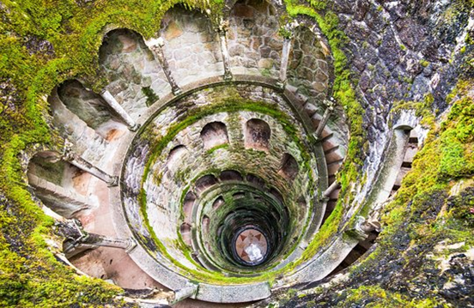

(Picture from Google Images)

Here she will have to try to find the way to the other exit and at the same time she will have to run from the monster, which has found her. To help her, she will have small rooms in which she can hide without being seen by the Demogorgon.

At the center of the maze there is a staircase, similar to the one in the picture but carved by the Demogorgon. As Eleven descends it she sees the Demogorgon following her on the other side. Towards the end a part of it is missing and she falls into a gigantic cave, the lair of the monster.



(Picture from Google Images)

The first room is the biggest, but it is also flooded. Eleven has to be careful not to make too much sound. As she proceeds, she hears the Demogorgon around her, but they can’t see each other.

Guil: “We are close, we can do it”

B11: “I don’t want to do it”

Guil: “What?”

B11: “I don’t want her to die. She is too little”

Abazu: “You don’t have to do it, you could help her”

Cati: “She must do it. She’s come too far to stop now”

Abazu: “But what if we all tried to get out without killing someone else? As a family”

Cati: “I don’t need a family”

Guil: “I want to kill my family too, now shut up before the Demogorgon finds us or I swear I’ll find a way to leave you with it for the rest of your days”

In the second room some Demodogs are sleeping peacefully. It is here that they grow and rest, while the Demogorgon takes care of them and feeds them. Eleven will have to be extremely quiet If she wants to get out alive.

B11: “A little girl like she is..all alone..down here..”

Guil: “She will soon be dead and no longer alone”

Raiden: “I wonder how these monsters see or feel the world around them. Maybe we could find a way to defeat them”

Cati: “Or maybe we could use the power of the little girl to make them do what we want. Take back our lives in the real world”

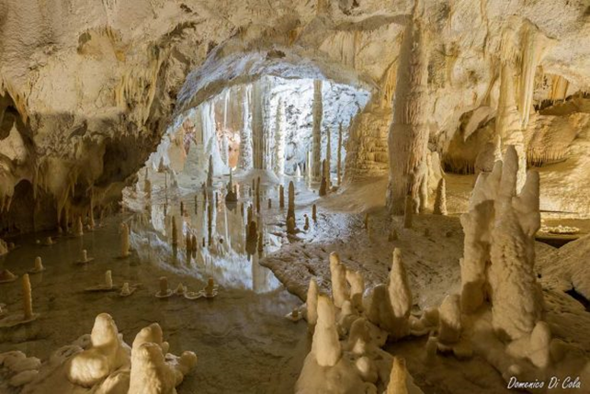

(Picture from Google Images)

As she enters the last room, Eleven notices the pendant on a pinnacle. The whole cave seems very unstable and silent, except for the sound of drops of water falling. As she approaches the other children start talking to her.

Raiden: “Be careful, don’t make a sound. Even a whisper could make it all fall”

Guil: “Oh yeah, and how do you know?”

Raiden: “I liked to read remember? Papa always gave me books”

Cati: “Spare us the part where you tell us how much Papa loved you, you poor thing. You ended up here like the rest of us”

Abazu: “Maybe we should stop it and concentrate on what we need to do?”

Cati: “Says the one sold like a slave. Family really loved you uh?”

Abazu: “How do you know?”

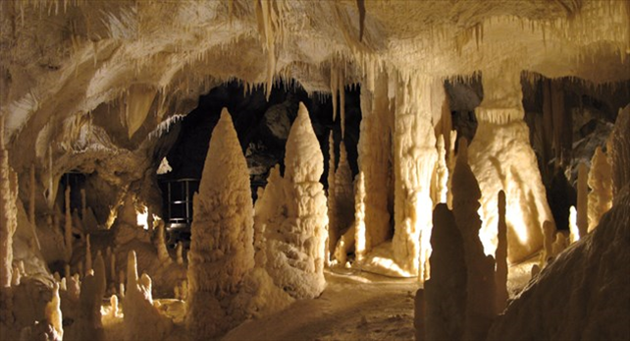

(Picture from Google Images)

Cati: “I remember Papa talking about someone they *bought*. With actual money. He used to joke about it a lot with the other scientists”

Abazu: “They didn’t sell me. I sold myself. For them. I don’t believe you, Papa was a good man, he wouldn’t..”

Guil: “Was he? Why don’t you tell him about all the times he put you into confinement cells Eleven?”

B11: “Please just shut up”

Eleven manages to take hold of the necklace, but the other children won’t let her alone.

Guil: “Maybe some memories will help you remember why you want to kill that little girl and go back to the real world”

B11: “Papa is dead”

Cati: “But the others aren’t”

B11: “Stop it”

Guil: “They beat me and kept me in chains”

Cati: “They locked me in my room for days, just like you”

B11: “STOP!”

As she screams, she hears a rumble coming from the ceiling. The whole cave starts collapsing, the stalactites start falling all over the place.

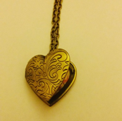

Raiden: “There! A squeeze!”

Eleven rushes towards it and enters it. The tunnel is dark and narrow, but she manages to crawl until the end of it. She finds herself under a bookshelf in the archives under the Library, so she pushes it away and goes back to Zasha.

As she arrives in the room where Zasha is, she finds her sleeping on the floor, curled under a dirty blanket. She could wake her up and give her the necklace back, or just stab her and take her soul and powers. Without conferring with the other children, Eleven wakes Zasha up and hands her the necklace. The little girl opens it, stares at the picture hidden inside it and starts crying.

B11: “What? What happened?”

Zasha: “This my mother. Never see her, just this. But I know this my mother”

B11: “You have never seen her? Why?”

Zasha: “She leave me. Orphanage? In Russia, cold, alone, afraid”

B11: “And then? What happened? Why did you end up here?”

Zasha: “Doctors came. Said I dangerous. Took me away and studied. Then they hurt me, really bad and tell me things. America bad, America hurt me. And then took me to America, leave me like mother”

B11: “And Papa found you? He saved you?”

Zasha: “He no Papa, he no save. He put me in cage, use electricity on me. Hurt me like doctors in Russia. I always sleep, they fear me. On day I try to run and arrive here. I no like it here, but library is safe, monster keep me safe”

B11: “Don’t worry, I am here now. You’re safe with me. I won’t hurt you. Now try to sleep, before we escape from this place”

Zasha smiles and returns to the place where she was sleeping. She closes her eyes, her cheeks still wet. While she waits for Zasha to fall asleep Eleven is tortured by doubt. She really wants to go back to the real world, but she doesn’t want to kill an innocent child.

B11: “I won’t do it. I will tell her the truth, make her trust me, make her use her powers and get out”

Abazu: “She is way stronger than I was, I’m not sure you could make her trust you again, if you told her that you killed us”

Guil: “And you’d always have someone you must rely on. Someone who could just want to go back to Russia and look for her damned mother. You need to take her powers”

Cati: “Or just kill her for the sake of killing her. You killed us all, why should you stop now?”

B11: “She doesn’t deserve the pain”

Cati: “Oh did we? If only I was still alive I swear I would..”

Guil: “We help you come this far, kill her. And once you did you can go back to the real world and avenge us all. Destroy everything you want. You would be the most powerful being ever existed, no one could stop you. Us”

Abazu: “Or maybe you could make something up. The real Eleven is your twin, she sent you here, hurt you like they hurt her and you need help to kill her”

Guil: “She is way too powerful to let her live. She could stop us all. Do you want to be stopped? Again?”

With her hands shaking, Eleven draws the knife she stole from Will’s house. She is as close to Zasha as she can get, holding her breath in fear of waking her up, but she hesitates. This murder would take her too far, she doesn’t want to hurt Zasha, but at the same time this seems her only choice to regain her freedom. With closed eyes she stabs Zasha multiple times. The last thing the little girl says before dying is “you hurt me”. After this her soul enters the necklace and Eleven takes hold of it. Her vision is blurred with tears.

Attracted by the smell of blood, the Demogorgon comes running. The children hear it coming up the stairs.

Raiden: “Use her power, now. Control it.”

Eleven does it and the Demogorgon stops on the threshold. It worked. Guilherme and Catinca laugh happily, whereas the other remain silent.

Guil: “Let’s go back to the Lab. With its strength we can open a passage to the Portal and finally go back”

## 14.2. Event diagram

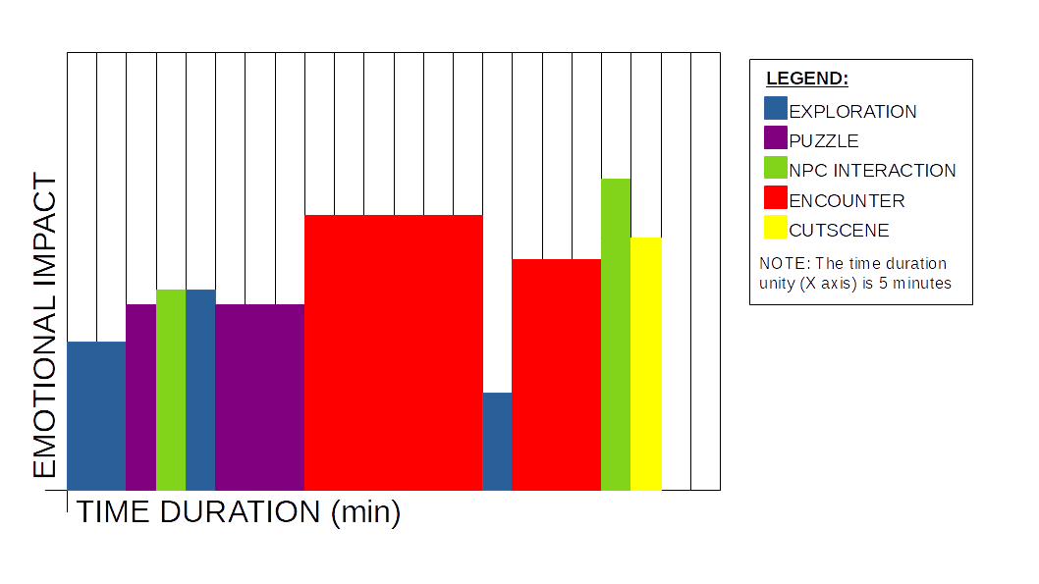

## 14.3. Level diagram & Description

The level is made by different floors that develop downwards as shown in the figure.

The overall height is approximately 50 meters (see specific sections for exact dimensions).

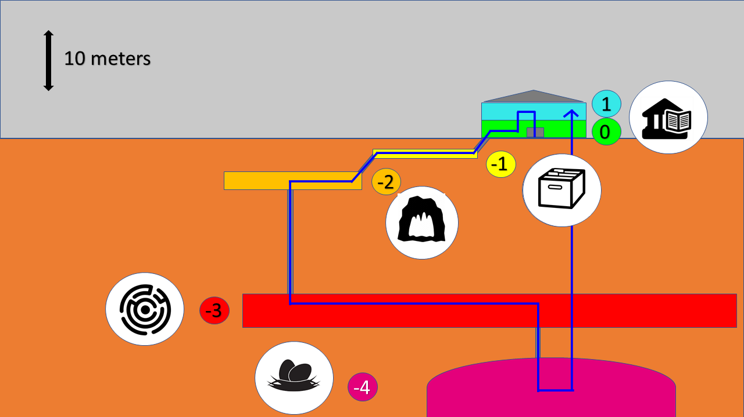

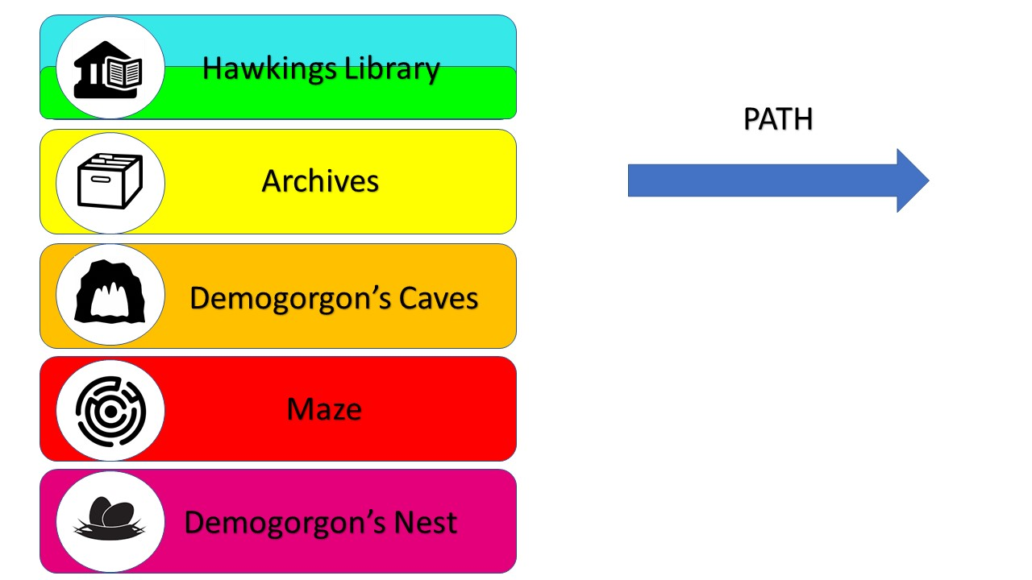

The three highest levels (-1, 0, 1) compose the public Hawkings Library. More in particular, this is a two-level building plus a basement that is the library archive.

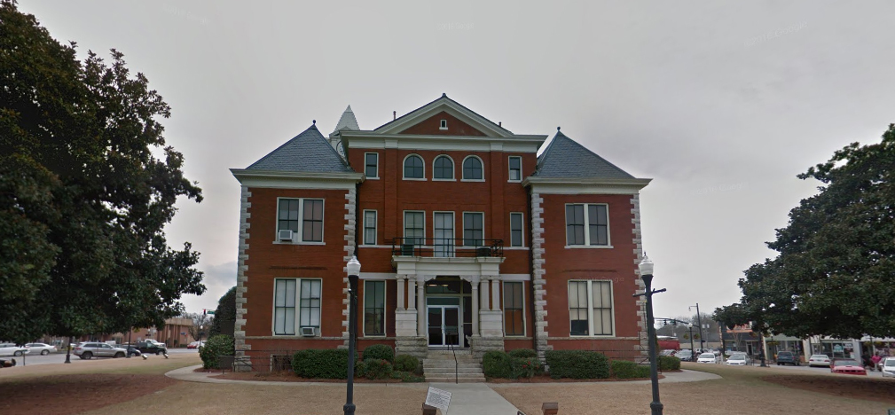

(Picture from Google Images)

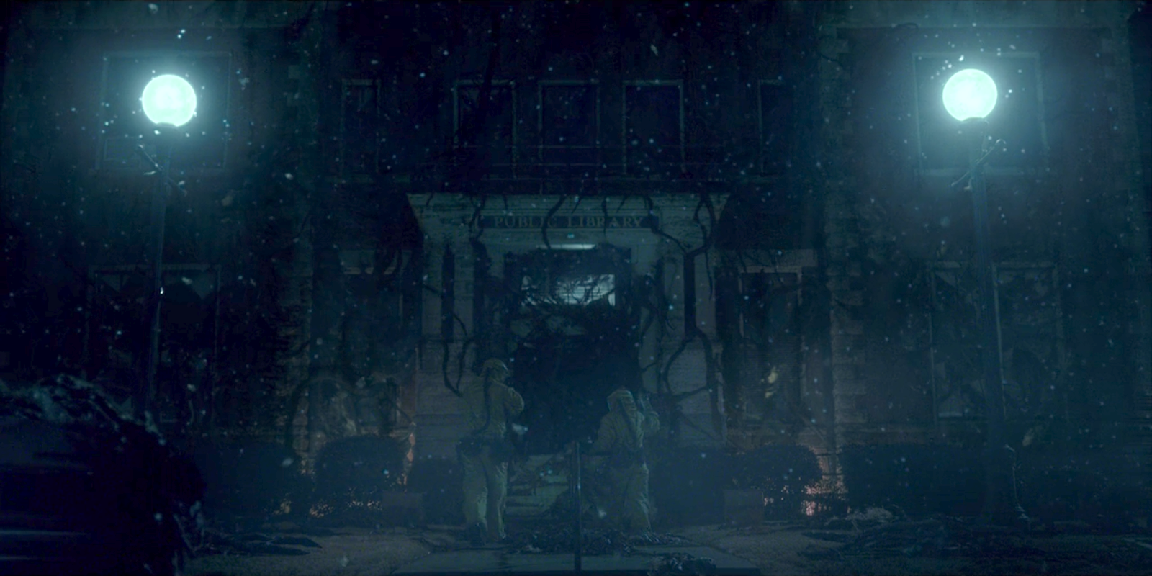

(Screenshot from Stranger Things, season 1)

Below the basement there is an underground tunnel structure created by the demo-creatures that form a real maze layered on 2 levels (floors -2, -3) that lead to the real nest of the Demogorgon (floor -4).

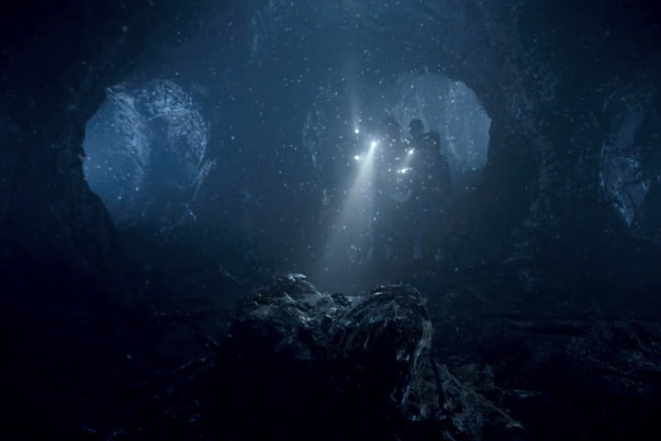

(Picture from Google Images)

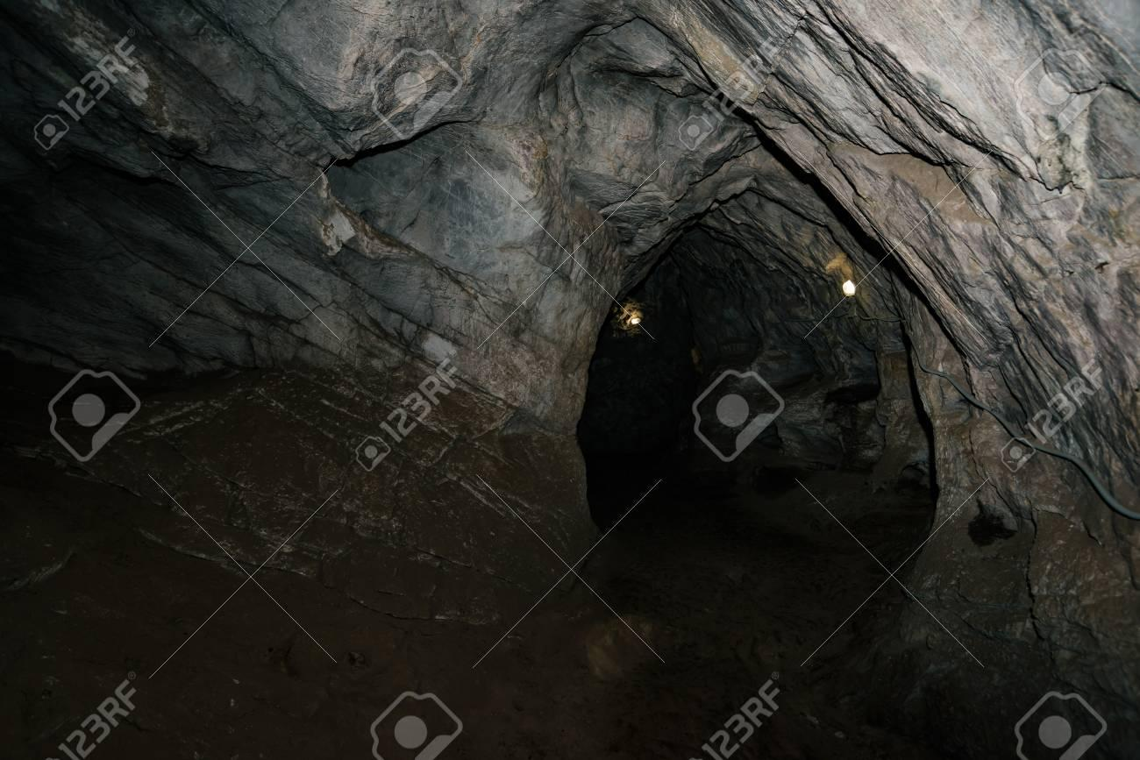

(Picture from Google Images)

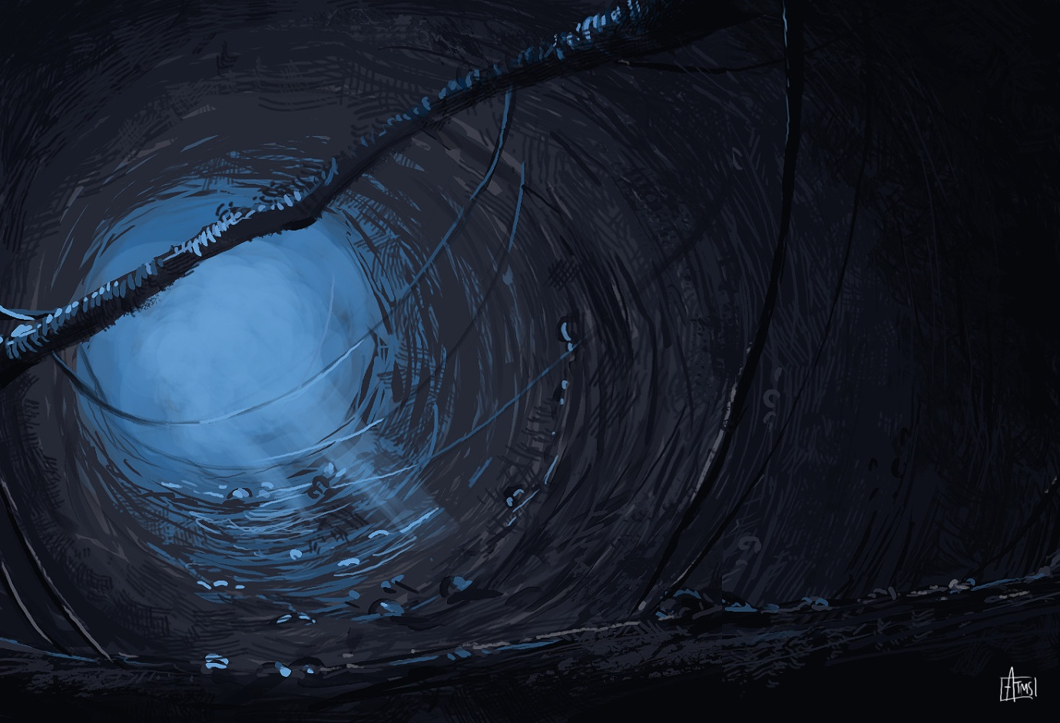

(Picture from Google Images)

All the blueprints showed in the next sections are in scale, so it is possible to calculate the dimensions of all the elements represented in them starting from the dimensions provided (relative to the three spatial axes).

Moreover, since Minecraft (which employs blocks) has been used as the environment creation tool, it was established that the size of a block is 0.5 x 0.5 x 0.5 m.

### 14.3.1. Floor 0: Hawkings library ground floor

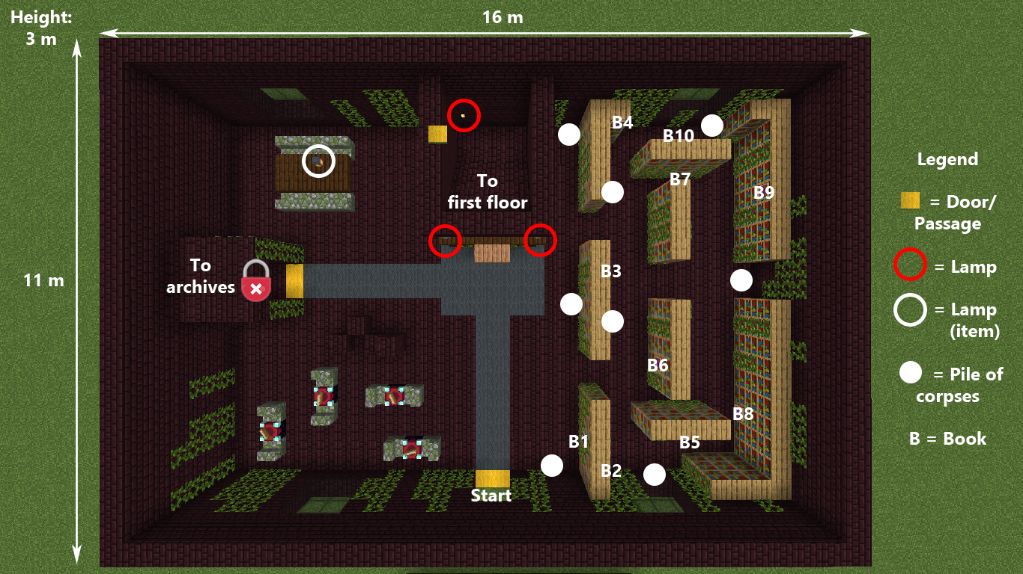

(Screenshot from Minecraft prototype, Floor 0 - Library Blueprint)

The player starts at the entrance of the library and the wall surrounding the entrance is covered in black vines. They can peek inside the library from one of the two windows located at the side of the entrance. From the right window he will see a little insight of what the shelves area look like and from the left side window he will see the library’s relax room and the hall. The relax room is composed of several tables and some of them have an old book on the surface.

In front of the entrance there is a desk with some lamps spreading a feeble light nearby.

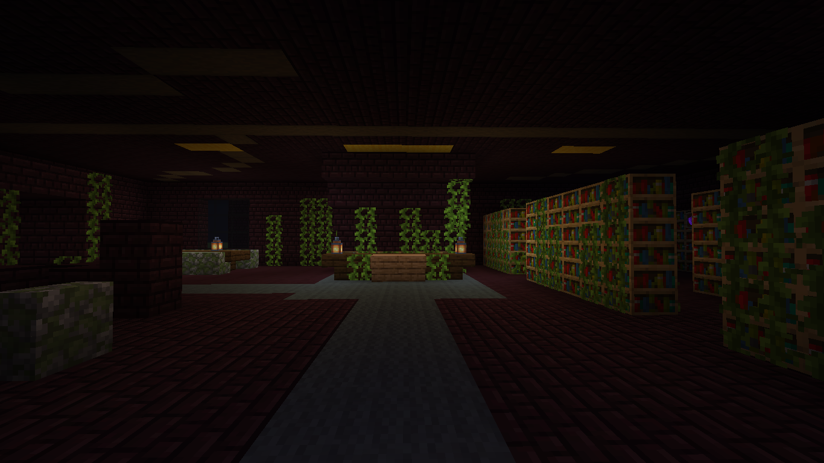

(Screenshot from Minecraft prototype, Floor 0 - Entrance front view)

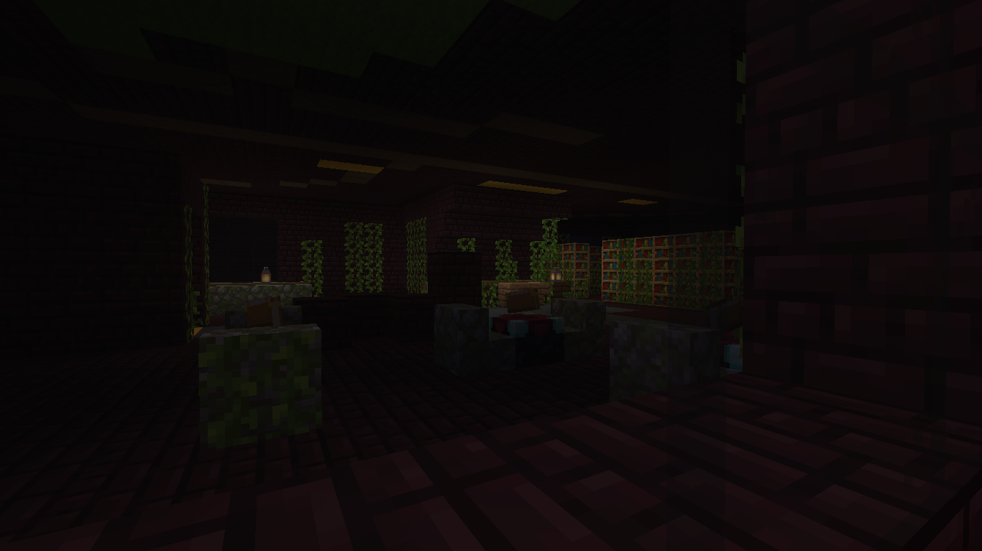

(Screenshot from Minecraft prototype, Floor 0 - Left window view)

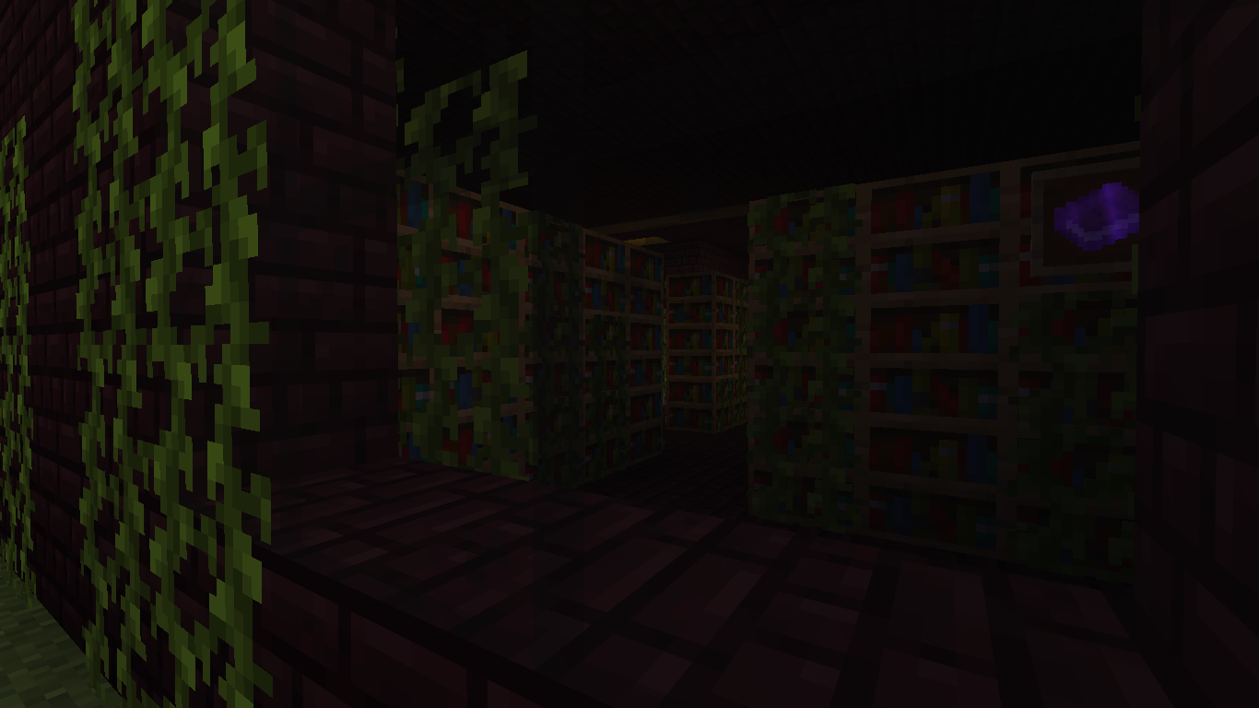

(Screenshot from Minecraft prototype, Floor 0 - Right window view)

As the player enters, they will struggle to see the surroundings clearly and so they will go right at the front counter, where there will be lamps emitting a feeble light. To get a better view of the surroundings the player will take one of the lamps (more specifically, the one on the table in the top-left corner of the room, see **Library Blueprint** for the exact position).

The right side of the library is filled with shelves of books. Some of these books are interactable and can be read (see **Library Blueprint** for the exact positions):

* B1. *The Little Prince* by Antoine de Saint-Exupéry
* B2. *To the lighthouse* by Virginia Wolf
* B3. *Indigenous races of the earth* by Josiah C. Nott
* B4. *Treasure Island* by Robert Louis Stevenson
* B5 *The Overcoat*, by Nikolai Gogol
* B6. *Dracula* by Bram Stoker
* B7. *Oroonoko* by Aphra Ben
* B8. *Poetry* by Fernando Pessoa
* B9. *Hagakure* by Yamamoto Tsunetomo
* B10. An Orienteering Manual

On the left side of the room there is a door covered in vines but it can’t be opened because of them and only Zasha will be able to open this door by controlling the mind of the vines.

At the top left of the room there is a large table (2m x 1m). If the player stands near this table and looks toward counter they can notice that behind that there is a door that leads to the upper floor.

This area is an introductory one that the player will explore in order to find Zasha, the little girl with the mind control ability, who will be upstairs. Obviously this area will be characterized by scary sounds and environmental events but there won’t be any life threats for the player as the Demogorgon lives far under the library. The player has to feel a continuous tension throughout this area, especially in the shelves sub-area because it is the most intricate part of this floor, resembling both the labyrinth that the player will face far below and the inner conflict B11 has.

An example can be taken from one of the final monster chases in Outlast 2 where the player is constantly feeling confused and trapped inside the Catholic Church Library.

(Full video reference is available on the web-site)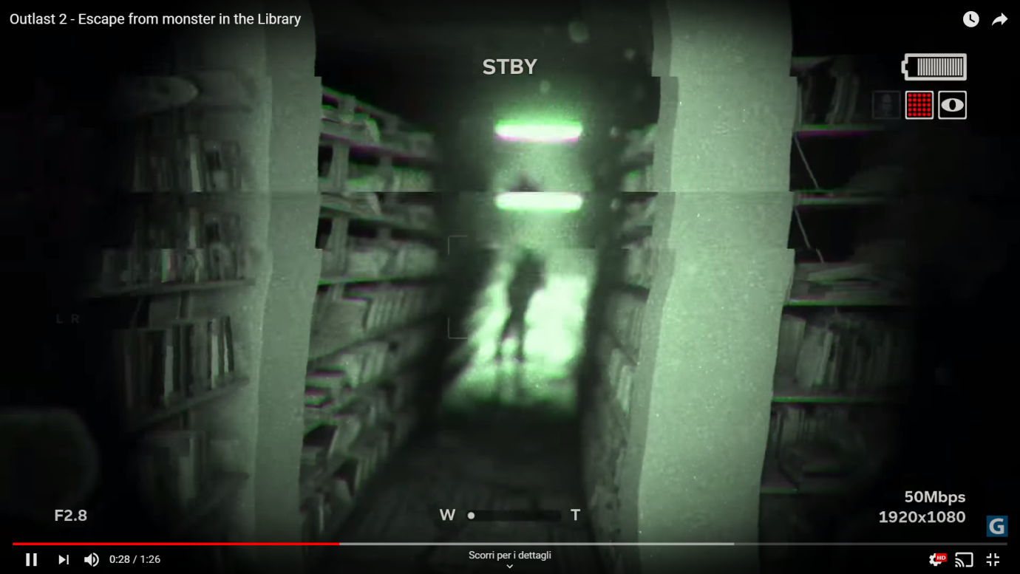

Other classical ‘jump-scare’ like events present in this area are books falling from the shelves and background voices and noises.

**Sounds:**

- Flipping pages

- Book being removed from shelf

- Footsteps on dirt

- Growls

- Howling wind

- Lantern flame burning

- Jumpscare sound

### 14.3.2. Floor 1: Hawkings library first floor

### 

(Screenshot from Minecraft prototype, Floor 1 - Library Blueprint)

After reaching the first floor, the player immediately faces a long corridor, which connects the four rooms present on this floor. The first thing the player can see is a series of vines that cover the entire corridor. More specifically, there are three main branches that solidly flow towards the door of the upper-left room forming a knot that covers the roots of a fourth one; the door is therefore locked, and it cannot be directly opened.

The player must look for the roots of these vines (the order is not important) positioned in the other three rooms and burn them in order to unlock the above door. To do so, the player has to follow the flow of the branches and find these roots.

#### Bottom-left room

In this room, the roots are behind a large and sturdy bookcase, and the passage to go to the back of the latter is blocked by a stone boulder. The power of telekinesis must be used to move the boulder, so the player can get access to the roots and burn them.

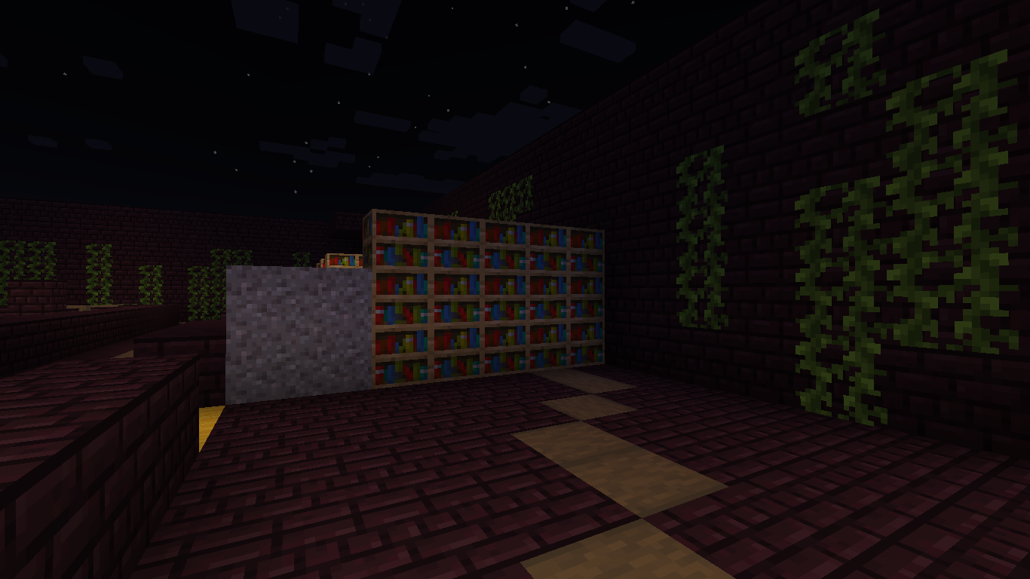

(Screenshot from Minecraft prototype, Floor 1 - Puzzle 1)

#### Bottom-right room

Here, the roots are located above a bookcase at the end of the room; since the player cannot directly use fire balls to burn the roots, they have to get closer by using the power of levitation. Once they reach the top of the bookcase, they player can finally use the fire power to burn the roots.

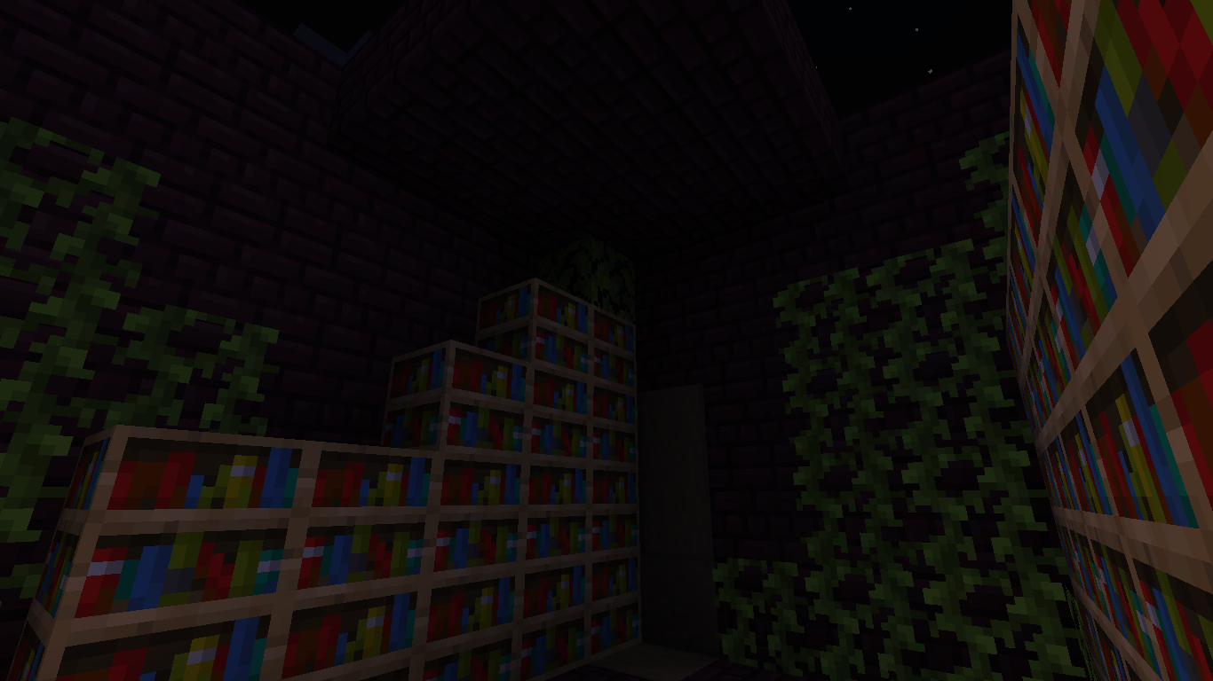

(Screenshot from Minecraft prototype, Floor 1 - Puzzle 2)

#### Top-right room

In this room a part of the floor has collapsed and the roots are on the other side of the room. The player must use the power of super speed to get past the hole and burn the roots.

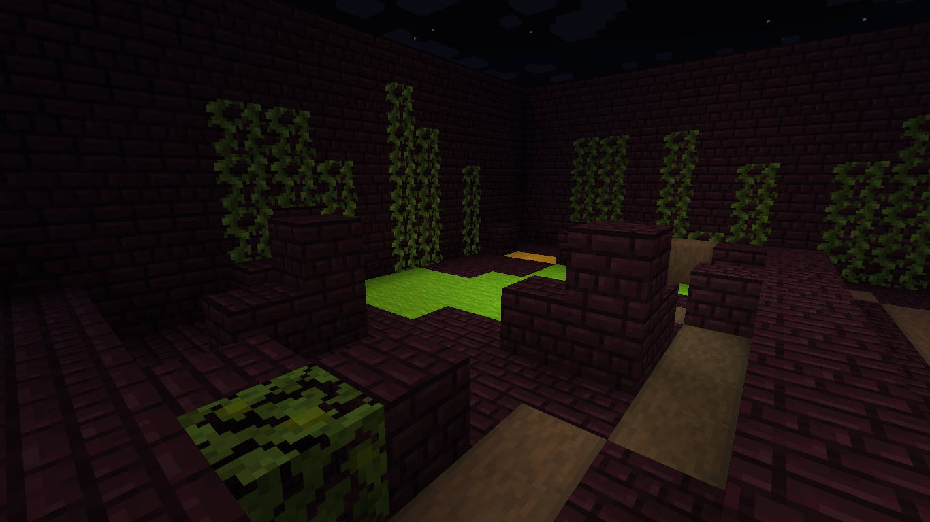

(Screenshot from Minecraft prototype, Floor 1 - Puzzle 3)

#### Top-left room

Once the above roots are burned, the player can finally burn the roots that lock the door leading to Zasha, thus unlocking it. After entering the room, the player finds Zasha hidden in a corner near a bookcase.

Approaching her will trigger a cutscene, showing a dialogue between the two girls (see section 14.1 to read the dialogue).

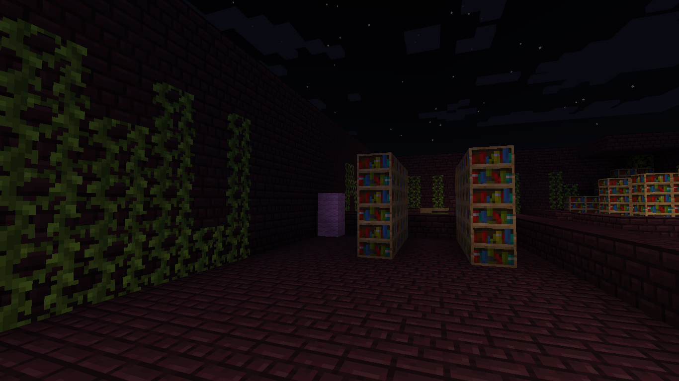

(Screenshot from Minecraft prototype, Floor 1 - Zasha’s room)

During this dialogue Zasha asks a favor to Bad Eleven, that is, to recover Zasha's necklace in the Demogorgon's nest. A new quest is therefore assigned; moreover, the door on the left of the ground floor leading to floor -1 (the archives) will unlock.

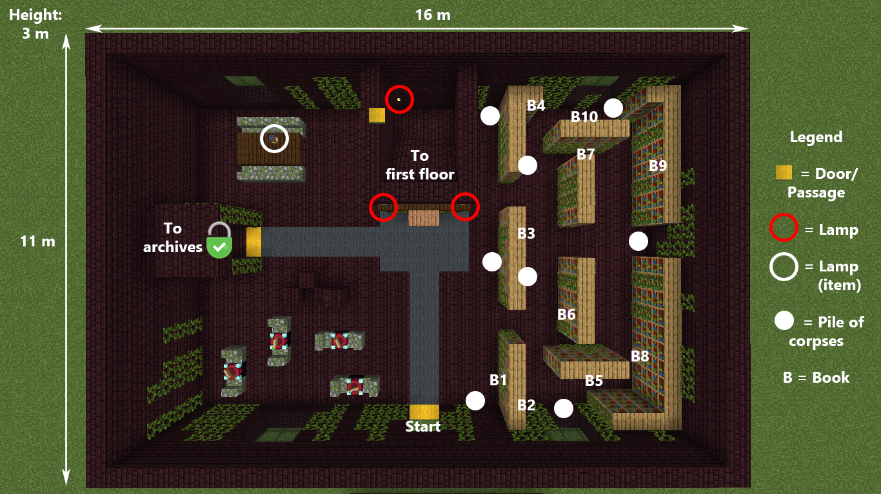

(Screenshot from Minecraft prototype, Floor 0 - Archives door unlocked)

Despite the fact that Zasha is scared and afraid of Bad Eleven, she will still act as a friendly NPC.

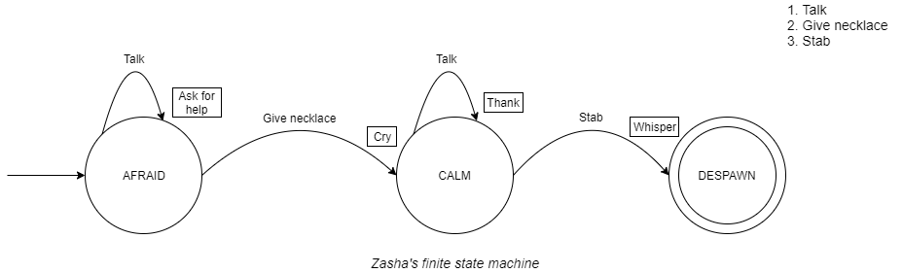

The player cannot harm Zasha in any way, and if they try to do so the other children will intervene discouraging Bad Eleven to do anything harmful to her since the former needs her power. Moreover, the emotion control is of no use since Bad Eleven already employed it to calm Zasha during the dialogue between them.

After giving the necklace to her, she will change state: however, the player cannot still harm her at will, since they will be forced to murder her just before the final cutscene that ends the level (see section 14.1 to read the dialogue).

**Sounds**:

- Steps

- Lantern flame burning

- Levitation swish

- Fire ball thrown

- Girl cries

- Vines burning

- Howling wind

### 14.3.3. Floor -1: Hawkings library archives

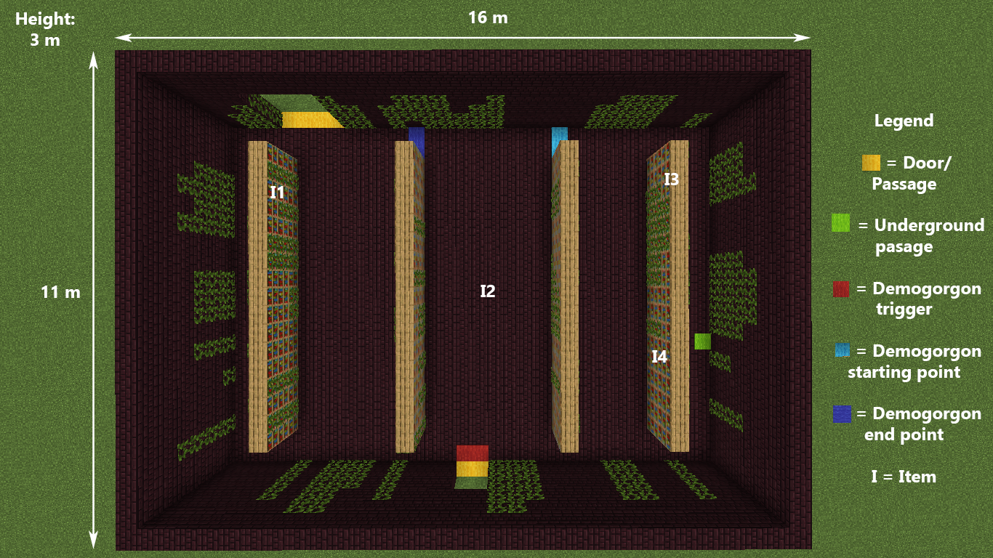

(Screenshot from Minecraft prototype, Floor -1 - Archives Blueprint)

This is a rectangular room filled with several shelves full of books perpendicular to the entrance door. There are no windows, the walls are covered with vines and so the ceiling where the vines are hanging down resembling black stalactites. Everything is completely swallowed by the darkness, the only light source is the lamp holded by the player.

As the player enters an event is triggered showing the Demogorgon rushing from the right to the left of the room. However, when the player gets closer, the Demogorgon can’t be found. (See the image above)

A “Large waffle” item situated at the center of the room is immediately spottable.

On the wall opposing the entrance on the other side of the room there is a hole large enough to allow a small sized car to pass through it. At the first glance, is understandable that this hole is caused by the Demogorgon. In fact that is the passage that leads to its nest.

Beside the “Large waffle” there are several other items that the player can pick up. So, before continuing, entering in the hole the player can explore the room and collect the following items (see **Archives Blueprint** for the exact location):

* 1x Medium waffle
* 1x Large waffle
* 1x Peanut-butter waffle

**Sounds**:

- Demogorgon growl

- Steps running

- Steps

- Jumpscare sound

### 14.3.4. Floor -2: Demogorgon’s Caves

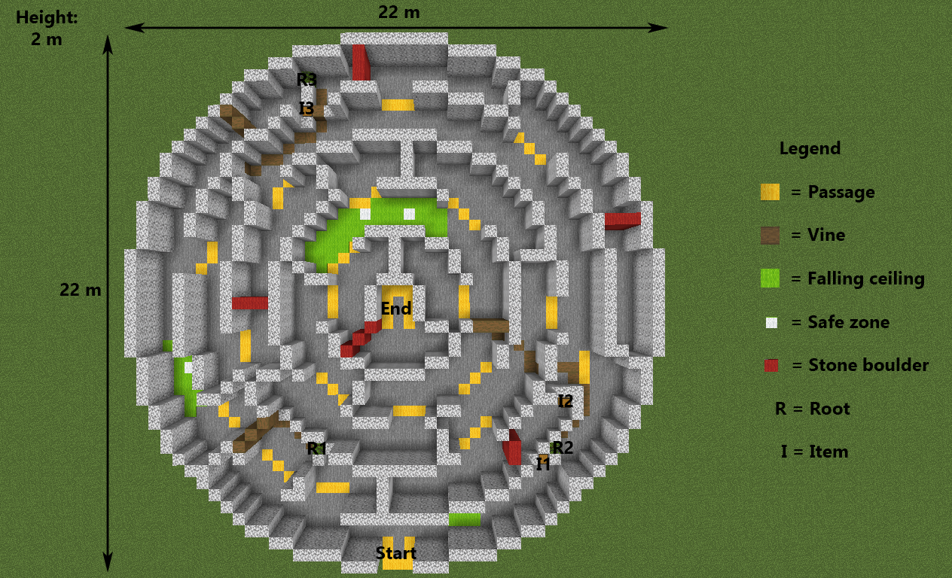

(Screenshot from Minecraft prototype, Floor -2 - Demogorgon’s Caves Blueprint)

It is a maze-like cave system digged out by the Demogorgon under the library and connected to the archives.

The path is dark and sometimes blocked by roots or by pieces of collapsed ceiling that the player must remove or avoid by using their powers.

To remove roots the player must search for the their origin and burn that point, while they can move away rocks with telekinesis.

In some parts of the cave the floor is about to collapse and the player must use super speed to cross these parts as quickly as possible while moving through small safe areas in which the ceiling will not crumble. After having reached the end of the caves the player enters the maze.

In this cave 3 items can be found by the player in some of the dead ends of the system, sometimes even behind roots or rocks, the object that can be collected are:

* 1x Medium waffle
* 2x Large waffle

**Sounds**:

- Steps on dirt

- Running steps

- Levitation swish

- Fire ball thrown

- Cave sounds

- Stones falling and rolling

### 14.3.5. Floor -3: Maze

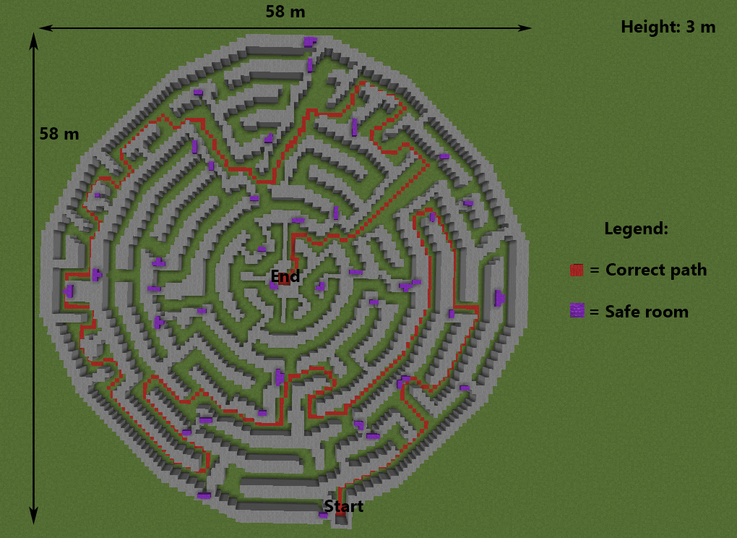

(Screenshot from Minecraft prototype, Floor -3 - Maze)

Maze digged out by the Demogorgon, where it roams in search for B11, since it heard her arrive. It is dark and damp, and even with the lamp the player’s field of view is very limited.

The Demogorgon and the player move through the maze at the same time and the player must be careful to hide from the monster when its near them, and they can do so by entering small crevices in the walls, waiting for the Demogorgon to go away.

In particular, the Demogorgon moves through the maze following a random route; however, it cannot find itself too far from the player, since there is a maximum range (15 meters) from the player within which it will always move.

If the Demogorgon spots the player, it will rush towards to location where it located them and, if it catches the player, the protagonist dies and must restart from the start of the maze.

The player enters this maze from the cave system located above it and connected through a tunnel. It’s located directly above the Demogorgon’s lair, that it’s accessible from a hole digged in the middle of the maze.

The path shown in red is the correct one to the objective.

**Sounds**:

- Cave sounds

- Steps on dirt

- Howling

- Running steps

- Demogorgon growl

- Water flowing

### 14.3.6. Floor -4: Demogorgon’s Lair

The last and lowest floor is the Demogorgon’s lair, it’s a very large cave divided in 3 sections by rock walls, the player gets in this area from an opening in the ceiling, dropping down in the first room.

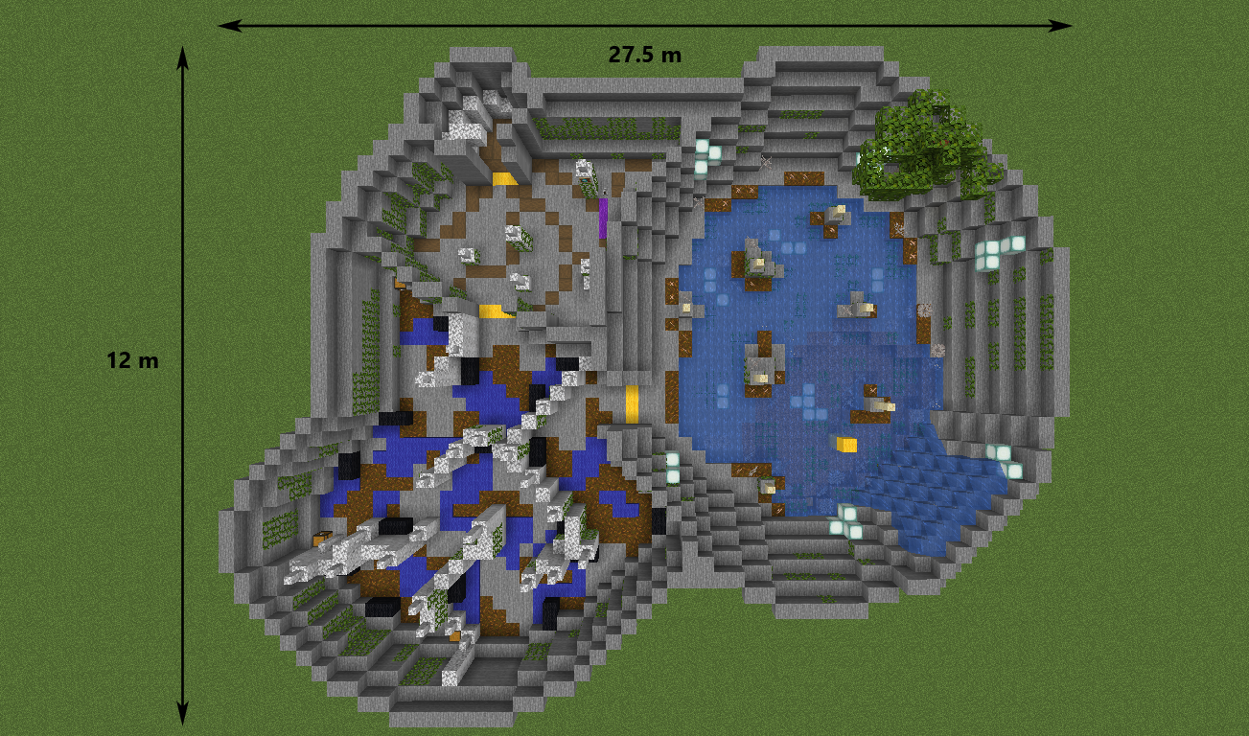

(Screenshot from Minecraft prototype, Floor -4 - Demogorgon’s Lair Blueprint)

The first is a large cave with an underground lake and some vegetation like seaweed, corals or even small bushes and moss, in certain areas of this cave the water is deeper and the player must swim or levitate above the water, there are also small crystals embedded in the walls that emit feeble white light.

The environment presents sounds of water flowing, whispers and steps to keep the player on edge.

At the bottom of the deepest part of the lake, the player can dive to pick up an item from the floor, which is:

* 1x Peanut-butter waffle

**Sounds**:

- Steps in water

- Swimming

- Water flowing

- Water falling

- Whispers

- Growls

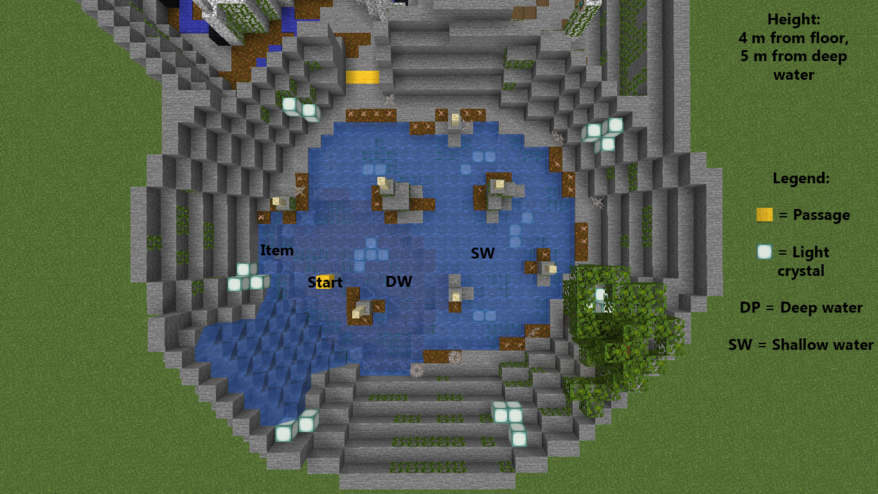

(Screenshot from Minecraft prototype, Floor -4 - Main room detail)

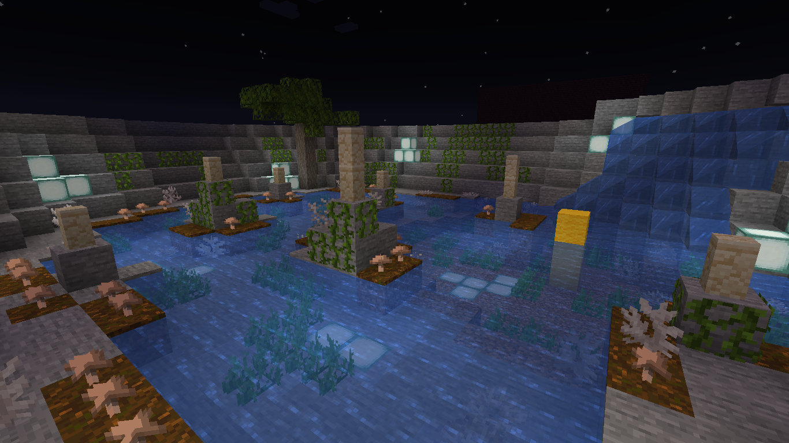

(Screenshot from Minecraft prototype, Floor -4 - First room view)

The second part is the Demodogs’ lair, and here are some of these creatures sleeping. The player must avoid making noise by jumping or levitating above the various puddles scattered through the cave, else the creatures will wake up and attack the player, forcing him to fight or run away. The cave is full of rock formations that block the player from going straight to the exit, so he must find the correct path between these rocks.

Here the player will hear the sound of drops of water falling, that grows louder and faster when they approach the demodogs.

In the northest part of the cave, three items are scattered on the floor, fairly hidden from the player, so these require some exploration of the area to be found. The items are:

* 1x Small waffle
* 1x Medium waffle
* 1x Large waffle

**Sounds**:

- Water flowing

- Drops of water falling

- Steps

- Steps on water

- Running steps

- Demodogs growl

- Demodogs bark

- Howl

- Breathing Demodogs

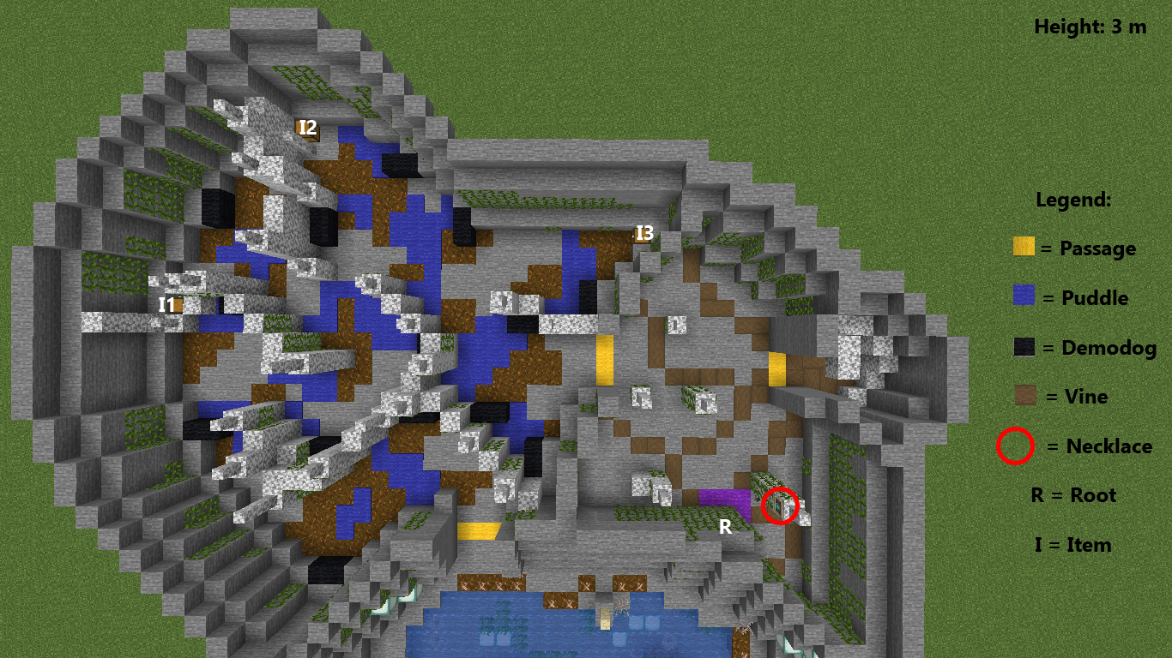

(Screenshot from Minecraft prototype, Floor -4 - Secondary rooms detail)

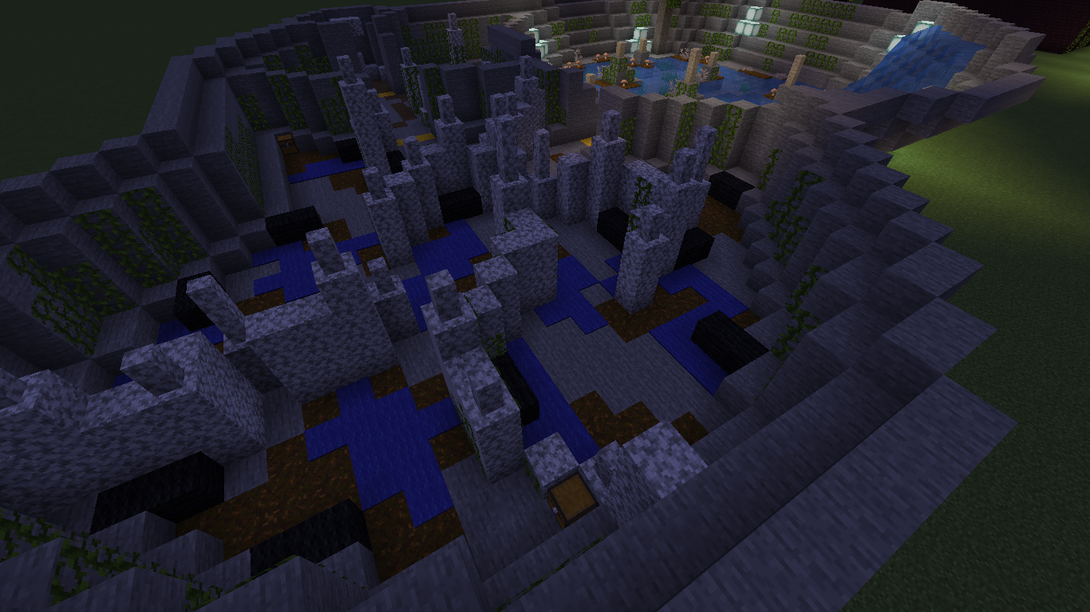

(Screenshot from Minecraft prototype, Floor -4 - Second room view)

The last part is the root cave, where Zasha’s pendant is located. There the player will find a massive root that needs to be burned to let them return to the surface through a spiral staircase naturally embedded in the rock walls. The origin of this root is hidden by a collapsed wall (indicated by the purple mark on the map) that the player discovers after collecting the pendant (after the cutscene where Bad Eleven screams and causes the entire cave to collapse, see secton 14.1).

The room is very quiet, the steps B11 takes will appear really loud, even though they are not. When the ceiling collapses there is a loud noice of stones falling.

**Sounds**:

- Stones falling

- Screams

- Running steps

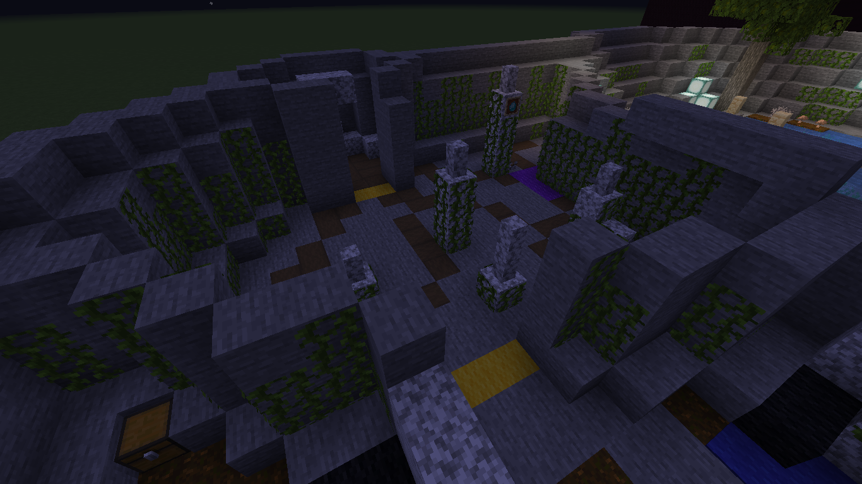

(Screenshot from Minecraft prototype, Floor -4 - Third room view)

15. Look & Feel

In this chapter there are some images (all taken from Google Images) of similar games from the point of view of the aspect to show the Look & Feel of the game.

### Outlast 1 and 2

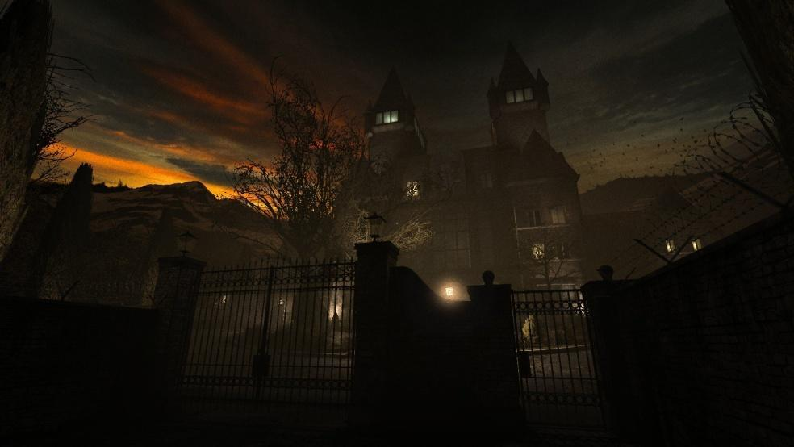

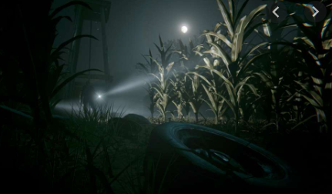

### Stranger Things (TV-series Upside Down)

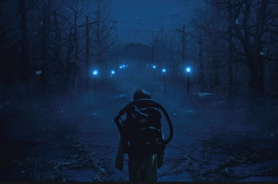

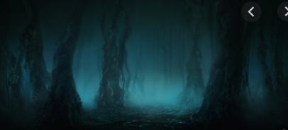

### Penumbra Necrologue

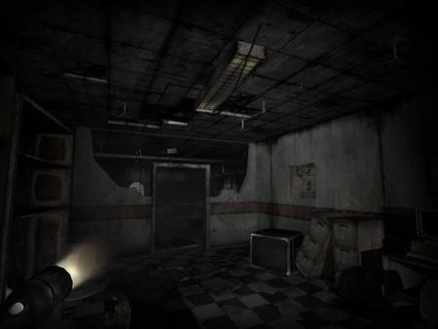

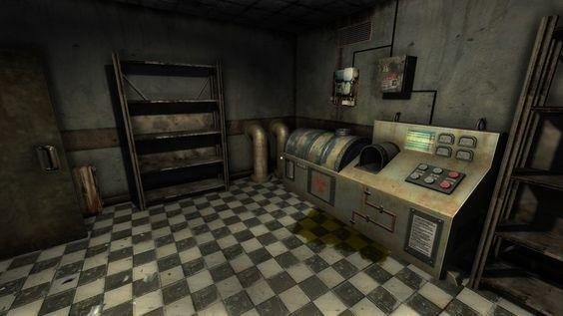

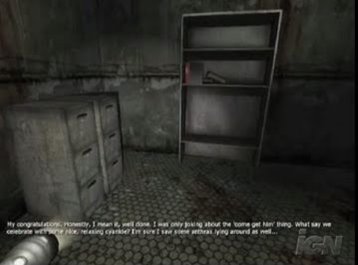

### Eleusis

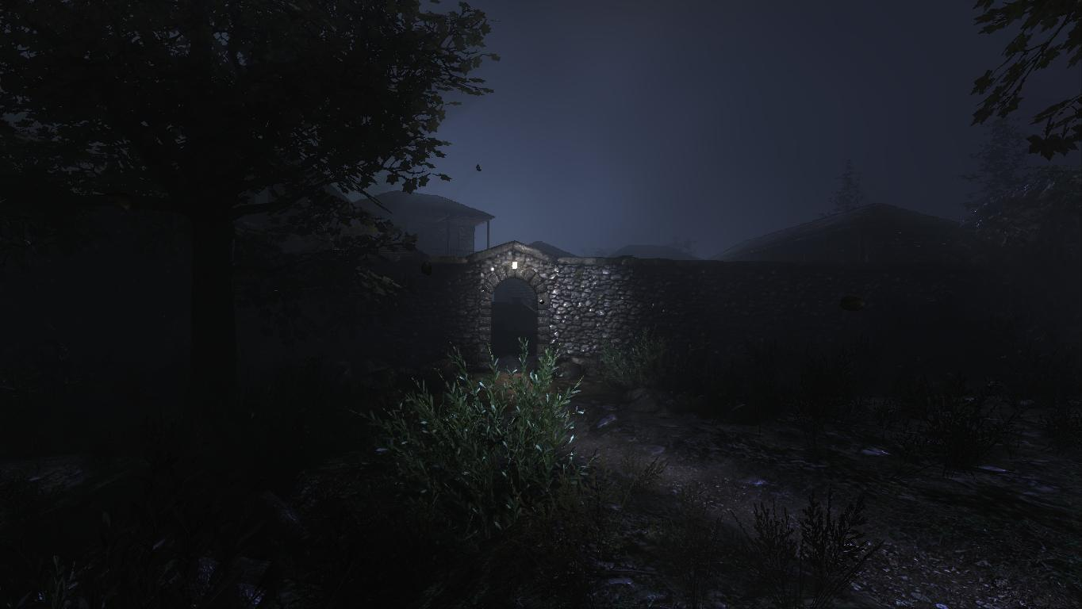

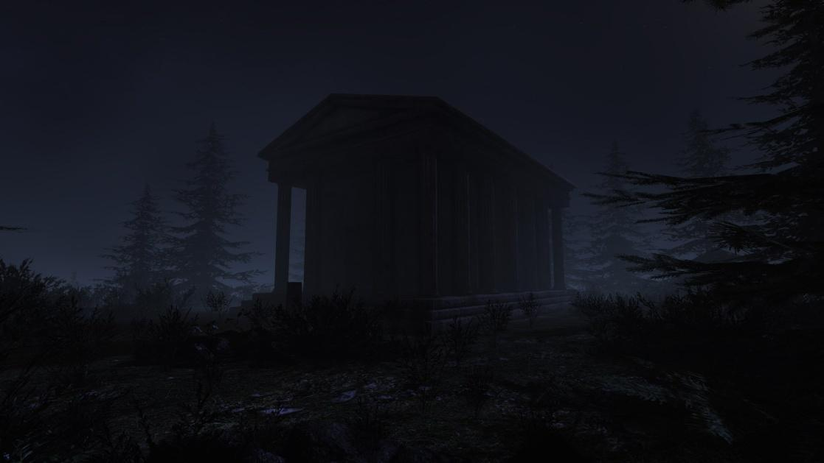

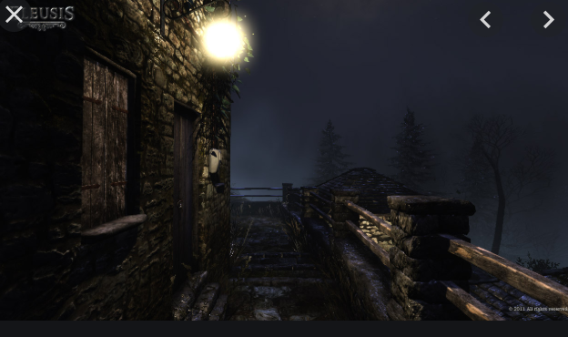

Unforgiving, a northern hymn

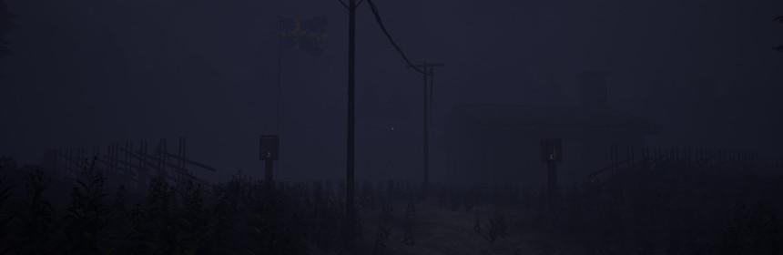

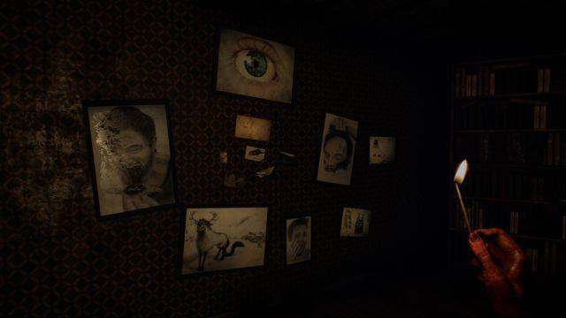

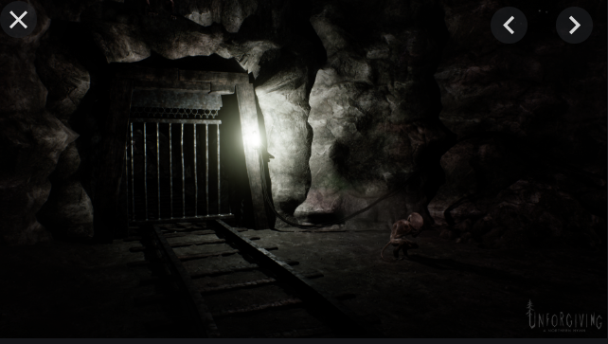

The above images represent a portion of the reference images. A complete collection of references (both images and videos) can be found on *The Eleventh Dice* website:

<https://nicolobuganza.wixsite.com/ted-becoming11>.